**STEADY STATE THERMAL ANALYSIS OF HEAT EXCHANGERS OF VARIOUS THERMAL MATERIALS**

A project Report submitted in partial fulfilment of the requirement for the award of the degree of

# BACHELOR OF TECHNOLOGY

**IN**

# MECHANICAL ENGINEERING

Submitted by

P.GOWTHAMI POORNIMA 16VV1A0339

S.MAHABOOB BASHA 17VV5A0361

CH.V.D.S.RAMYA 16VV1A0308

CH.PRASAD BABU 16VV1A0307

P.SAMPATH 16VV1A0338

Under the Esteemed guidance of

SRI K.SRINIVAS PRASAD, M.Tech

Assistant professor

Department Of Mechanical Engineering

JNTUK UCEV, Vizianagaram



DEPARTMENT OF MECHANICAL ENGINEERING

UNIVERSITY COLLEGE OF ENGINEERING VIZIANAGARAM

JAWAHARLAL NEHRU TECHNOLOGICAL UNIVERSITY KAKINADA

2016-2020

DEPARTMENT OF MECHANICAL ENGINEERING

UNIVERSITY COLLEGE OF ENGINEERING VIZIANAGARAM

JAWAHARLAL NEHRU TECHNOLOGICAL UNIVERSITY KAKINADA

2016-2020



CERTIFICATE

This is to certify that the main project entitled **“Steady State Thermal Analysis of Heat Exchangers of Various Thermal Materials”** is a bonafide work of

P.GOWTHAMI POORNIMA 16VV1A0339

S.MAHABOOB BASHA 17VV5A0361

CH.V.D.S.RAMYA 16VV1A0308

CH.PRASAD BABU 16VV1A0307

P.SAMPATH 16VV1A0338

A Project report Submitted in partial fulfilment of the requirement for the award of degree of Bachelor of Technology in Mechanical Engineering from JNTUK University College of Engineering, Vizianagaram during the years 2016 to 2020.

**PROJECT GUIDE HEAD OF THE DEPARTMENT**

**SRI K. SRINIVAS PRASAD**, **M. Tech** Dr. C.NEELIMA DEVI, M.E, PH.D

Assistant professor Assistant Professor

Department of Mechanical Engineering Department of Mechanical Engineering

**EXTERNAL EXAMINER**

ACKNOWLEDGEMENT

We would like to express our deep sense of gratitude to **Sri K.SRINIVAS PRASAD, M.Tech,** Assistant Professor of Mechanical Engineering department for his whole hearted co-operation, unfailing inspiration and valuable guidance throughout the project work, his useful suggestions, constant support has gone a long way in his valuable time.

We would like to express our deep sense of gratitude to our Head of the Mechanical department **Dr.C.NEELIMA DEVI, M.E, Ph.D.**, for her whole hearted co-operation, unfailing inspiration and valuable guidance throughout the project work, her useful suggestions, constant support has gone a long way in her valuable time.

We feel happy to convey our sincere thanks to our principal of JNTUK UCEV **Dr.G.SWAMI NAIDU, B.E, M.E, and Ph.D.,** for her kind cooperation.

We are thankful to all the faculty members of mechanical department and lab technicians of engineering workshop.

P.GOWTHAMI POORNIMA (16VV1A0339)

S.MAHABOOB BASHA (17VV5A0361)

CH.V.D.S.RAMYA (16VV1A0308)

CH.PRASAD BABU (16VV1A0307)

P.SAMPATH (16VV1A0338)

**ABSTRACT**

This project consists of simplified models of counter flow heat exchangers having both interacting liquids (hot and cold fluids) as water.We have designed different heat exchangers to cool water from 95°c to 38°c by water which has inlet and outlet temperatures as 22°c and 45°c respectively. Then the steady state thermal simulation in ANSYS has been performed by applying several thermal loads. The heat transfer capabilities of several thermal materials has been compared by assigning different materials to various parts such as tubes, coils, shell. The materials chosen were of great importance and widely used in practice such as copper, aluminium and structural steel.

We have also designed heat exchangers with conventional and advanced materials like composite materials. Carbon fiber composites are currently being used for high heat transfer applications. Carbon fibers are known to have excellent thermal conductivities. The result obtained shows that by assigning copper - Graphene composite to all the parts we have got the best possible value of thermal flux amongst the discussed materials.

**CONTENTS**

1. **INTRODUCTION 1**

1.1. CLASSIFICATION OF HEAT EXCHANGERS 2

1.2. TUBULAR HEAT EXCHANGERS 2

1.2.1. SHELL AND TUBE HEAT EXCHANGERS 2

1.2.2. DOUBLE PIPING HEAT EXCHANGERS 3

1.2.3. SHELL AND COIL HEAT EXCHANGERS 3

1.3. INTRODUCTION TO COMPOSITE MATERIALS 5

**2. LITERATURE SURVEY 9**

**3. PROBLEM FORMULATION 11**

**4. SOLUTION METHOD 12**

4.1. SHELL AND TUBE HEAT EXCHANGERS 12

4.1.1. MAKING SOLID MODEL: COPPER AS MATERIAL 12

4.1.2 STEADY STATE THERMAL SIMULATION 13

4.1.3. MAKING SOLID MODEL: ALUMINUM AS MATERIAL 15

4.1.4. STEADY STATE THERMAL SIMULATION 16

4.1.5. MAKING SOLID MODEL: STRUCTURAL STEEL AS MATERIAL 18

4.1.6. STEADY STATE THERMAL SIMULATION 19

4.1.7 MAKING SOLID MODEL: SILICON CARBIDE AS MATERIAL 21

4.1.8. STEADY STATE THERMAL SIMULATION 22

4.1.9. MAKING SOLID MODEL: COPPER-GRAPHENE AS MATERIAL 24

4.1.10. STEADY STATE THERMAL SIMULATION 25

4.2. DOUBLE PIPING HEAT EXCHANGERS 27

4.2.1. MAKING SOLID MODEL: COPPER AS MATERIAL 27

4.2.2. STEADY STATE THERMAL SIMULATION 28

4.2.3. MAKING SOLID MODEL: ALUMINUM AS MATERIAL 30

4.2.4. STEADY STATE THERMAL SIMULATION 31

4.2.5. MAKING SOLID MODEL: STRUCTURAL STEEL AS MATERIAL 33

4.2.6. STEADY STATE THERMAL SIMULATION 34

4.2.7 MAKING SOLID MODEL: SILICON CARBIDE AS MATERIAL 36

4.2.8. STEADY STATE THERMAL SIMULATION 37

4.2.9 MAKING SOLID MODEL: COPPER - GRAPHENE AS MATERIAL 39

4.2.10. STEADY STATE THERMAL SIMULATION 40

4.3. SHELL AND COIL HEAT EXCHANGERS 42

4.3.1MAKING SOLID MODEL: COPPER AS MATERIAL 42

4.3.2. STEADY STATE THERMAL SIMULATION 43

4.3.3. MAKING SOLID MODEL: ALUMINUM AS MATERIAL 45

4.3.4. STEADY STATE THERMAL SIMULATION 46

4.3.5. MAKING SOLID MODEL: STRUCTURAL STEEL AS MATERIAL 48

4.3.6. STEADY STATE THERMAL SIMULATION 49

4.3.7. MAKING SOLID MODEL: SILICON CARBIDE AS MATERIAL 51

4.3.8. STEADY STATE THERMAL SIMULATION 52

4.3.9. MAKING SOLID MODEL: COPPER- GRAPHENE AS MATERIAL 54

4.3.10. STEADY STATE THERMAL SIMULATION 55

5. CONCLUSION

REFERENCES

**FIGURES**

1.1. CLASSIFICATION OF HEAT EXCHANGERS 2

1.2. SHELL AND TUBE HEAT EXCHANGER 3

1.3. DOUBLE PIPE HEAT EXCHANGER 4

4.1. SHELL AND TUBE HEAT EXCHANGER MODEL (COPPER) 13

4.2. TEMPERATURE RESULTS OF SHELL AND TUBE HEAT EXCHANGER (COPPER) 14

4.3. TOTAL HEAT FLUX OF SHELL AND TUBE HEAT EXCHANGER (COPPER) 14

4.4. SHELL AND TUBE HEAT EXCHANGER MODEL (ALUMINUM) 16

4.5. TEMPERATURE RESULTS OF SHELL AND TUBE HEAT EXCHANGER (ALUMINUM) 17

4.6. TOTAL HEAT FLUX OF SHELL AND TUBE HEAT EXCHANGER

(ALUMINIUM) 17

4.7. SHELL AND TUBE HEAT EXCHANGER MODEL (STRUCTURAL STEEL) 19

4.8. TEMPERATURE RESULTS OF SHELL AND TUBE HEAT EXCHANGER (STRUCTURAL STEEL) 20

4.9. TOTAL HEAT FLUX OF SHELL AND TUBE HEAT EXCHANGER (STRUCTURAL STEEL) 20

4.10. SHELL AND TUBE HEAT EXCHANGER MODEL (SILICON CARBIDE) 22

4.11. TEMPERATURE RESULTS OF SHELL AND TUBE HEAT EXCHANGER (SILICON CARBIDE) 23

4.12. TOTAL HEAT FLUX OF SHELL AND TUBE HEAT EXCHANGER (SILICON CARBIDE) 25

4.13. SHELL AND TUBE HEAT EXCHANGER MODEL (COPPER-GRAPHENE) 25

4.14. TEMPERATURE RESULTS OF SHELL AND TUBE HEAT EXCHANGER (COPPER-GRAPHENE) 26

4.15. TOTAL HEAT FLUX OF SHELL AND TUBE HEAT EXCHANGER (COPPER-GRAPHENE) 26

4.16. TUBE IN TUBE HEAT EXCHANGER MODEL (COPPER) 28

4.17. TEMPERATURE RESULTS OF TUBE IN TUBE HEAT EXCHANGER (COPPER)

29

4.18. TOTAL HEAT FLUX OF TUBE IN TUBE HEAT EXCHANGER (COPPER) 29

4.19. TUBE IN TUBE HEAT EXCHANGER MODEL (ALUMINUM) 31

4.20. TEMPERATURE RESULTS OF TUBE IN TUBE HEAT EXCHANGER (ALUMINUM) 32

4.21. TOTAL HEAT FLUX OF TUBE IN TUBE HEAT EXCHANGER (ALUMINUM) 32

4.22. TUBE IN TUBE HEAT EXCHANGER MODEL (STRUCTURAL STEEL) 34

4.23. TEMPERATURE RESULTS OF TUBE IN TUBE HEAT EXCHANGER (STRUCTURAL STEEL) 35

4.24. TOTAL HEAT FLUX OF TUBE IN TUBE HEAT EXCHANGER (STRUCTURAL STEEL) 35

4.25. TUBE IN TUBE HEAT EXCHANGER MODEL (SILICON CARBIDE) 37

4.26. TEMPERATURE RESULTS OF TUBE IN TUBE HEAT EXCHANGER (SILICON CARBIDE) 38

4.27. TOTAL HEAT FLUX OF TUBE IN TUBE HEAT EXCHANGER (SILICON CARBIDE) 38

4.28. TUBE IN TUBE HEAT EXCHANGER MODEL (COPPER-GRAPHENE) 40

4.29. TEMPERATURE RESULTS OF TUBE IN TUBE HEAT EXCHANGER (COPPER-GRAPHENE) 41

4.30. TOTAL HEAT FLUX OF TUBE IN TUBE HEAT EXCHANGER (COPPER-GRAPHENE) 41

4.31. SHELL AND COIL HEAT EXCHANGER MODEL (COPPER) 43

4.32. TEMPERATURE RESULTS OF SHELL AND COIL HEAT EXCHANGER (COPPER) 44

4.33. TOTAL HEAT FLUX OF SHELL AND COIL HEAT EXCHANGER (COPPER) 44

4.34. SHELL AND COIL HEAT EXCHANGER MODEL (ALUMINUM) 56

4.35. TEMPERATURE RESULTS OF SHELL AND COIL HEAT EXCHANGER (ALUMINUM) 47

4.36. TOTAL HEAT FLUX OF SHELL AND COIL HEAT EXCHANGER (ALUMINUM)

47

4.37. SHELL AND COIL HEAT EXCHANGER MODEL (STRUCTURAL STEEL) 49

4.38. TEMPERATURE RESULTS OF SHELL AND COIL HEAT EXCHANGER (STRUCTURAL STEEL) 50

4.39. TOTAL HEAT FLUX OF SHELL AND COIL HEAT EXCHANGER (STRUCTURAL STEEL) 50

4.40. SHELL AND COIL HEAT EXCHANGER MODEL (SILICON CARBIDE) 52

4.41. TEMPERATURE RESULTS OF SHELL AND COIL HEAT EXCHANGER (SILICON CARBIDE) 53

4.42. TOTAL HEAT FLUX OF SHELL AND COIL HEAT EXCHANGER (SILICON CARBIDE) 53

4.43. SHELL AND COIL HEAT EXCHANGER MODEL (COPPER-GRAPHENE) 55

4.44. TEMPERATURE RESULTS OF SHELL AND COIL HEAT EXCHANGER (COPPER-GRAPHENE) 56

4.45. TOTAL HEAT FLUX OF SHELL AND COIL HEAT EXCHANGER (COPPER-GRAPHENE) 56

**TABLES**

4.1. GEOMETRY OF SHELL AND TUBE HEAT EXCHANGER (COPPER) 12

4.2. STEADY STATE THERMAL LOADS ON HEAT EXCHANGER (COPPER) 13

4.3. TOTAL HEAT FLUX VALUES OF HEAT EXCHANGER (COPPER) 15

4.4. GEOMETRY OF SHELL AND TUBE HEAT EXCHANGER (ALUMINIUM) 15

4.5. STEADY STATE THERMAL LOADS ON HEAT EXCHANGER (ALIMINIUM) 16

4.6. TOTAL HEAT FLUX VALUES OF HEAT EXCHANGER (ALUMINIUM) 18

4.7. GEOMETRY OF SHELL AND TUBE HEAT EXCHANGER (STRUCTURAL STEEL)

18

4.8. STEADY STATE THERMAL LOADS ON HEAT EXCHANGER (STRUCTURAL STEEL) 19

4.9. HEAT FLUX VALUES OF HEAT EXCHANGER (STRUCTURAL STEEL) 21

4.10. GEOMETRY OF SHELL AND TUBE HEAT EXCHANGER (SILICON CARBIDE) 21

4.11. STEADY STATE THERMAL LOADS ON HEAT EXCHANGER (SILICON CARBIDE) 22

4.12. HEAT FLUX VALUES OF HEAT EXCHANGER (SILICON CARBIDE) 24

4.13. GEOMETRY OF SHELL AND TUBE HEAT EXCHANGER (COPPER-GRAPHENE)

24

4.14. STEADY STATE THERMAL LOADS ON HEAT EXCHANGER (COPPER-GRAPHENE) 25

4.15. HEAT FLUX VALUES OF HEAT EXCHANGER (COPPER-GRAPHENE) 27

4.16. GEOMETRY OF DOUBLE PIPING HEAT EXCHANGER (COPPER) 27

4.17. STEADY STATE THERMAL LOADS ON HEAT EXCHANGER (COPPER) 28

4.18. TOTAL HEAT FLUX VALUES OF HEAT EXCHANGER (COPPER) 30

4.19. GEOMETRY OF DOUBLE PIPING HEAT EXCHANGER (ALUMINIUM) 30

4.20. STEADY STATE THERMAL LOADS ON HEAT EXCHANGER (ALUMINIUM) 31

4.21. TOTAL HEAT FLUX VALUES OF HEAT EXCHANGERS (ALUMINIUM) 33

4.22. GEOMETRY OF DOUBLE PIPING HEAT EXCHANGER (STRUCTURAL STEEL)

33

4.23. STEADY STATE THERMAL LOADS ON HEAT EXCHANGER (STRUCTURAL STEEL) 34

4.24. TOTAL HEAT FLUX VALUES OF HEAT EXCHANGER (STRUCTURAL STEEL)

36

4.25. GEOMETRY OF DOUBLE PIPING HEAT EXCHANGER (SILICON CARBIDE) 36

4.26. STEADY STATE THERMAL LOADS ON HEAT EXCHANGER (SILICON CARBIDE) 37

4.27. TOTAL HEAT FLUX VALUES OF HEAT EXCHANGER (SILICON CARBIDE) 39

4.28. GEOMETRY OF DOUBLE PIPING HEAT EXCHANGER (COPPER-GRAPHENE) 39

4.29. STEADY STATE THERMAL LOADS ON HEAT EXCHANGER (COPPER-GRAPHENE) 40

4.30. TOTAL HEAT FLUX VALUES OF HEAT EXCHANGER (COPPER-GRAPHENE) 42

4.31. GEOMETRY OF SHELL AND COIL HEAT EXCHANGER (COPPER) 42

4.32. STEADY STATE THERMAL LOADS ON HEAT EXCHANGER (COPPER) 43

4.33. TOTAL HEAT FLUX VALUES OF HEAT EXCHANGER (COPPER) 45

4.34. GEOMETRY OG SHELL AND COIL HEAT EXCHANGER (ALUMINIUM) 45

4.35. STEADY STATE THERMAL LOADS ON HEAT EXCHANGER (ALUMINIUM) 46

4.36. TOTAL HEAT FLUX VALUES OF HEAT EXCHANGER (ALUMINIUM) 48

4.37. GEOMETRY OF SHELL AND COIL HEAT EXCHANGER (STRUCTURAL STEEL)

48

4.38. STEADY STATE THERMAL LOADS ON HEAT EXCHANGER (STRUCTURAL STEEL) 49

4.39. TOTAL HEAT FLUX VALUES OF HEAT EXCHANGER (STRUCTURAL STEEL)

51

4.40. GEOMETRY OF SHELL AND COIL HEAT EXCHANGER (SILICON CARBIDE)

51

4.41. STEADY STATE THERMAL LOADS OF HEAT EXCHANGER (SILICON CARBIDE) 52

4.42. TOTAL HEAT FLUX VALUES OF HEAT EXCHANGER (SILICON CARBIDE) 54

4.43. GEOMETRY OF SHELL AND TUBE HEAT EXCHANGER (COPPER-GRAPHENE)

54

4.44. STEADY STATE THERMAL LOADS ON HEAT EXCHANGER (COPPER-GRAPHENE) 55

4.45. TOTAL HEAT FLUX VALUES OF HEAT EXCHANGER (COPPER-GRAPHENE)

57

**1. INTRODUCTION**

A heat exchanger is a device that is used to transfer thermal energy between two or more fluids, between a solid surface and a fluid, or between solid particulates and a fluid, at different temperatures and in thermal contact. In heat exchangers, there are usually no external heat and work interactions. Typical applications involve heating or cooling of a fluid stream of concern and evaporation or condensation of single- or multi component fluid streams. In other applications, the objective may be to recover or reject heat, or sterilize, pasteurize, fractionate, distill, concentrate, crystallize, or control a process fluid. In a few heat exchangers, the fluids exchanging heat are in direct contact. In most heat exchangers, heat transfer between fluids takes place through a separating wall or into and out of a wall in a transient manner. In many heat exchangers, the fluids are separated by a heat transfer surface, and ideally they do not mix or leak. Such exchangers are referred to as direct transfer type, or simply recuperators. In contrast, exchangers in which there is intermittent heat exchange between the hot and cold fluids—via thermal energy storage and release through the exchanger surface or matrix— are referred to as indirect transfer type, or simply regenerators. Such exchangers usually have fluid leakage from one fluid stream to the other, due to pressure differences and matrix rotation/valve switching. Common examples of heat exchangers are shell-and tube exchangers, automobile radiators, condensers, evaporators, air preheaters, and cooling towers. If no phase change occurs in any of the fluids in the exchanger, it is sometimes referred to as a sensible heat exchanger. There could be internal thermal energy sources in the exchangers, such as in electric heaters and nuclear fuel elements. Combustion and chemical reaction may take place within the exchanger, such as in boilers, fired heaters, and fluidized-bed exchangers. Mechanical devices may be used in some exchangers such as in scraped surface exchangers, agitated vessels, and stirred tank reactors. Heat transfer in the separating wall of a recuperator generally takes place by conduction. However, in a heat pipe heat exchanger, the heat pipe not only acts as a separating wall, but also facilitates the transfer of heat by condensation, evaporation, and conduction of the working fluid inside the heat pipe. In general, if the fluids are immiscible, the separating wall may be eliminated, and the interface between the fluids replaces a heat transfer surface, as in a direct-contact heat exchanger.

# 1.1 Classification of heat Exchangers

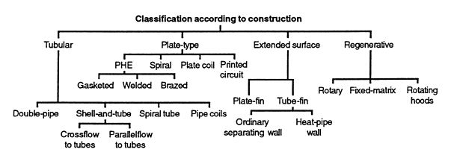

**FIGURE 1.1:** classification of heat exchangers

**1.2 Tubular Heat Exchangers:**

These exchangers are generally built of circular tubes, although elliptical, rectangular, or round/flat twisted tubes have also been used in some applications. There is considerable flexibility in the design because the core geometry can be varied easily by changing the tube diameter, length, and arrangement. Tubular exchangers can be designed for high pressures relative to the environment and high-pressure differences between the fluids. Tubular exchangers are used primarily for liquid-to-liquid and liquid-to-phase change (condensing or evaporating) heat transfer applications. They are used for gas-to-liquid and gas-to-gas heat transfer applications primarily when the operating temperature and/ or pressure is very high or fouling is a severe problem on at least one fluid side and no other types of exchangers would work. These exchangers may be classified as shell-and tube, double-pipe, and shell and coil exchangers. They are all prime surface exchangers except for exchangers having fins outside/inside tubes.

**1.2.1 Shell-and-Tube Exchangers:**

This exchanger, shown in below Figure is generally built of a bundle of round tubes mounted in a cylindrical shell with the tube axis parallel to that of the shell. One fluid flows inside the tubes, the other flows across and along the tubes. The major components of this exchanger are tubes (or tube bundle), shell, frontend head, rear-end head, baffles, and tube sheets, and are described briefly later in this subsection.

A variety of different internal constructions are used in shell-and-tube exchangers, depending on the desired heat transfer and pressure drop performance and the methods employed to reduce thermal stresses, to prevent leakages, to provide for ease of cleaning, to contain operating pressures and temperatures, to control corrosion, to accommodate highly asymmetric flows, and so on. Shell-and-tube

exchangers are classified and constructed in accordance with the widely used TEMA (Tubular Exchanger Manufacturers Association) standards (TEMA, 1999), DIN and other standards in Europe and elsewhere, and ASME (American Society of Mechanical Engineers) boiler and pressure vessel codes. TEMA has developed a notation system to designate major types of shell-and-tube exchangers. In this system, each exchanger is designated by a three-letter combination, the first letter indicating the front-end head type, the second the shell type, and the third the rear-end head type. These are identified in Fig. 1.6. Some common shell-and-tube exchangers are AES, BEM, AEP, CFU, AKT, and AJW. It should be emphasized that there are other special types of shell-and-tube exchangers commercially available that have front- and rear-end heads different from those in Fig. 1.6. Those exchangers may not be identifiable by the TEMA letter designation.

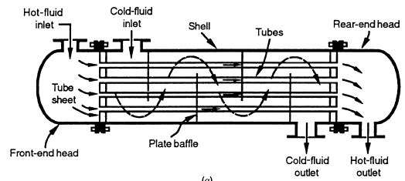

**FIGURE 1.2:** Shell-and-tube exchanger

**1.2.2 Double-Pipe Heat Exchangers:**

This exchanger usually consists of two concentric pipes with the inner pipe plain or finned, as shown in below figure. One fluid flows in the inner pipe and the other fluid flows in the annulus between pipes in a counter flow direction for the ideal highest performance for the given surface area. However, if the application requires an almost constant wall temperature, the fluids may flow in a parallel flow direction. This is perhaps the simplest heat exchanger. Flow distribution is no problem, and cleaning is done very easily by disassembly. This configuration is also suitable where one or both of the fluids is at very high pressure,

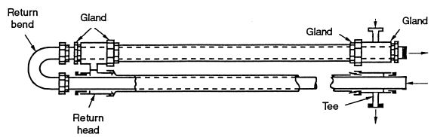

**FIGURE 1.3:** Double-pipe heat exchanger

because containment in the small-diameter pipe or tubing is less costly than containment in a large-diameter shell. Double-pipe exchangers are generally used for small-capacity applications where the total heat transfer surface area required is 50m2 (500 ft2) or less because it is expensive on a cost per unit surface area basis. Stacks of double-pipe or multitude heat exchangers are also used in some process applications with radial or longitudinal fins. The exchanger with a bundle of U tubes in a pipe (shell) of 150mm (6 in.) diameter and above uses segmental baffles and is referred to variously as a hairpin or jacketed U-tube exchanger.

**1.2.3 Shell and coil Heat Exchangers:**

This exchanger is generally built of round coils mounted in a cylindrical shell with the coils axis parallel to that of the shell. One fluid flows inside the coil, the other flows across and along the shell. The major components of this exchanger are coils and shell.

These consist of one or more wound coils fitted in a shell. Heat transfer rate associated with coil is higher than that for a straight tube. Thermal expansion is no problem, but cleaning is almost impossible.

# 1.3 Introduction to Composite materials:

A **composite material** (also called a **composition material** or shortened to **composite**, which is the common name) is a material made from two or more constituent materials with significantly different physical or chemical properties that, when combined, produce a material with characteristics different from the individual components. The individual components remain separate and distinct within the finished structure, differentiating composites from mixtures and solid solutions.

The new material may be preferred for many reasons. Common examples include materials which are stronger, lighter, or less expensive when compared to traditional materials.

Typical engineered composite materials include:

* Reinforced concrete  and masonry
* Composite wood such as plywood
* Reinforced plastics, such as fibre-reinforced polymer or fiberglass
* Ceramic matrix composites (composite ceramic and metal matrices)
* Metal matrix composites
* and other Advanced composite materials

Composite materials are generally used for buildings, bridges, and structures such as boat hulls , swimming pool panels, racing car bodies , shower stalls, bath tubs, storage tanks, imitation granite and cultured marble sinks and countertops.

The most advanced examples perform routinely on spacecraft and aircraft in demanding environments.

Composites tend to have the following characteristics:

* high strength;
* high modulus;
* low density;
* excellent resistance to fatigue, creep, creep rupture, corrosion, and wear;
* low coefficient of thermal expansion (CTE).

# Advantages and Disadvantages of Composites:

Composite parts have both advantages and disadvantages when compared to the metal parts they are being used to replace.

**Advantages of Composites**:

* A higher performance for a given weight leads to fuel savings. Excellent strength-toweight and stiffness-to-weight ratios can be achieved by composite materials. This is usually expressed as strength divided by density and stiffness (modulus) divided by density. These are so-called "specific" strength and "specific" modulus characteristics.
* Laminate patterns and ply build up in a part can be tailored to give the required mechanical properties in various directions
* It is easier to achieve smooth aerodynamic profiles for drag reduction. Complex double-curvature parts with a smooth surface finish can be made in one manufacturing operation.
* Part count is reduced.
* Production cost is reduced. Composites may be made by a wide range of processes.
* Composites offer excellent resistance to corrosion, chemical attack, and outdoor weathering; however, chemicals are damaging to composites (e.g., paint stripper),and new types of paint and stripper are being developed to deal with this. Some thermoplastics are not very resistant to some solvents.

**Disadvantages of Composites:**

* Composites are more brittle than wrought metals and thus are more easily damaged. Cast metals also tend to be brittle.
* Repair introduces new problems, for the following reasons: Materials require refrigerated transport and storage and have limited shelf lives. . Hot curing is necessary in many cases, requiring special equipment. Curing either hot or cold takes time. The job is not finished when the last rivet has been installed.
* If rivets have been used and must be removed, this presents problems of removal without causing further damage.
* Repair at the original cure temperature requires tooling and pressure.
* Composites must be thoroughly cleaned of all contamination before repair.
* Composites must be dried before repair because all resin matrices and some fibers absorb moisture.

# Silicon carbide:

**Silicon Carbide offers the following advantages:**

* Chemicals resistance to strong acids, bases, oxidants and chlorinated organics
* Completely impervious without the use of any impregnants
* Non-contaminating for high purity applications
* Excellent thermal conductivity resulting in efficient heat transfer and immunity to thermal shock
* Excellent mechanical properties and thermal shock resistance
* High erosion resistance allowing higher velocity and improved heat transfer

**Key features:**

* Excellent thermal conductivity of SiC
* Efficient heat transfer
* Resistant to thermal shock
* Excellent mechanical properties
* High erosion resistance
* Unique anticorrosive solution

**Customer benefits:**

* Design meets International standard (ASME, AS, PED...).
* Gasket free design available
* Compactness of the heat exchanger
* Long-time life
* Cost effective solution
* Local service

# Copper- Graphene Composite:

**Graphene** is considered as a promising reinforcing agent for **copper**-based materials due to the fact that **graphene**, possessing thermal conductivity higher than that of a pure **copper** (~ 5000 J/(m K s)

**Major advantages of graphene are;**

* It  is  the  thinnest  material  known  and  with  that  also  the strongest.
* It  consists   of  a  single  layer  of  carbon  atoms  and  is  both  pliable  and transparent.
* It is a superb conductor of both heat and electricity.
* It  is  used  in  the  production  of  high  speed  electronic  devices  responsible  for  fast  technological  changes.
* Chemical sensors effective at detecting explosives.

# Disadvantages of Graphene:

* Creation of high quality graphene is expensive and complex process.
* In order to grow graphene, toxic chemicals are being used at high temperatures. Due to this it exhibits toxic qualities.

# LITERATURE SURVEY

In the past decades the design and analysis of Shell and Tube Type Heat Exchanger has been done through various modes viz. theoretically, experimentally, by making solid models etc. However a lesser attention has been given on the heat transfer capabilities of the materials. It was due to practical limitations as well as it was also not possible to change the material of tubes or shell again and again and test them under the severe loading conditions. But, now the intense development of CAD facility has given us the tool by which we may introduce number of materials and their combinations to the actual working conditions, and henceforth find their accuracy and compatibility with the desired functions. The works reviewed that have done the same work in the described field are summarized as follows:

**Hari Haran et.al** proposed a counter flow heat exchanger and after designing it, made a solid model using PRO-E by using the derived dimensions and performed the steady state thermal simulation on ANSYS. For simplification of theoretical calculations they have also done a C code which is useful for calculating the thermal analysis of a counter flow of water-oil type shell and tube heat exchanger. They have compared the results obtained after thermal simulation and that obtained from the manual designing and found an error of 0.0274 in effectiveness.

**Paresh Patel** and **Amitesh Paul** had performed thermal analysis of shell and tube type heat exchanger using ANSYS, and CFD analysis has been carried out for different materials like steel, copper and aluminium and on the basis of results obtained they have described which material gives best heat transfer rates.

**A. Gopi** Chand et.al showed how to do the thermal analysis by using theoretical formulae and for this they had chosen a practical problem of counter flow shell and tube heat exchanger of water and oil type, by using the data that came from theoretical formulae, they designed a model of shell and tube heat exchanger using Pro-E and did the thermal analysis by using FLOEFD software and compared the result that obtained from FLOEFD software and theoretical formulae. For simplification of theoretical calculations they have also done a MATLAB code which is useful for calculating the thermal analysis of a counter flow of water-oil type shell and tube heat exchanger. The result after comparing both was that they were getting an error of 0.023 in effectiveness.

**P. S. Gowthaman** and **S. Sathish** proposed analysis of two different baffles in a shell and tube heat exchanger by using ANSYS FLUENT. It was found that the use of helical baffles in heat exchanger reduces Shell side pressure drop, pumping cost, weight, fouling etc as compared to segmental baffle for a new installation.

**Ender Ozden** and **Ilker Tari** had investigated the design of shell and tube heat exchanger by numerically modelling, in particular the baffle spacing, baffle cut and shell diameter dependencies of heat transfer coefficient and pressure drop. The flow and temperature fields are resolved by using a commercial CFD package and it is performed for a single shell and single tube pass heat exchanger with a variable number of baffles and turbulent flow. The best turbulent model among the one is selected to compare with the CFD results of heat transfer coefficient, outlet temperature and pressure drop with the Bell-Delaware method result. By varying flow rate the effect of the baffle spacing to shell diameter ratio on the heat exchanger performance for two baffle cut value is investigated.

**3. PROBLEM FORMULATION**

In this project we are concerned with the study of heat transfer capabilities of various thermal materials that are generally used for shells, tubes and coils of heat exchanger. The fact which is noticeable is that the purpose of heat exchange can be done through any moderate conductor of heat, however the study of material properties becomes necessary when we have to exchange a large amount of heat within a minimum stimulated time in order to meet out process and production standards as well as to secure the time economy. Also in the large installations it is always desired that the material could handle the overload situations as and when demanded, hence we may employ a good conductor instead of moderate one, but cannot use moderate one where good heat transfer capabilities is demanded. Under these circumstances it is inevitable to ensure the good heat transfer capabilities of the materials.

Here we are considering five materials viz. copper, aluminium, structural steel, silicon carbide and copper- graphene. We have to check their heat transfer capabilities under the designed conditions and select the most suitable one. We are also concerned about choosing an economical combination of materials assigned to shell, tubes and coils.

**4. SOLUTION METHOD**

In this project we have proposed a solid model of different heat exchangers. After generating the model we have put those parts under thermal loading conditions and solved out the same under steady state thermal simulation. The results obtained were quite familiar with general considerations about the hierarchical nature of thermal conductivities of the concerned materials. ANSYS 18.1 has been used for the purpose of model generation and its further analysis. The solution phase generally involved three major steps which are described in detail under next sub headings:

1. Making of solid model.
2. Steady state thermal simulation.

**4.1 Shell and tube heat exchangers:**

**4.1.1 Making of Solid Model: Copper as material**

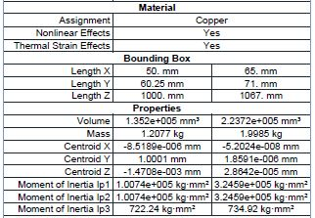

**Table 4.1:** geometry of shell and tube Heat exchanger (copper)

Using the dimensions of shell and tube shown in table-4.1, we have made a solid model using ANSYS 18.1. The parts in assembly are as shown in figure-4.1.

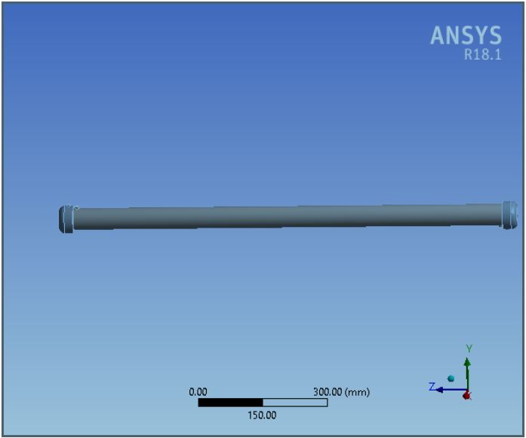

**FIGURE 4.1:** Shell and Tube Heat Exchanger model (Copper)

**4.1.2 Steady State Thermal Simulation:**

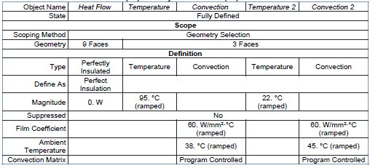

**Table 4.2:** Steady state thermal loads on Heat Exchanger (Copper)

This is the final and the most important step of our analysis. Here we have applied the thermal loads on the various faces and edges and simulated to get the value of thermal flux of the overall assembly. The thermal loads applied are shown in the figure-4.2.

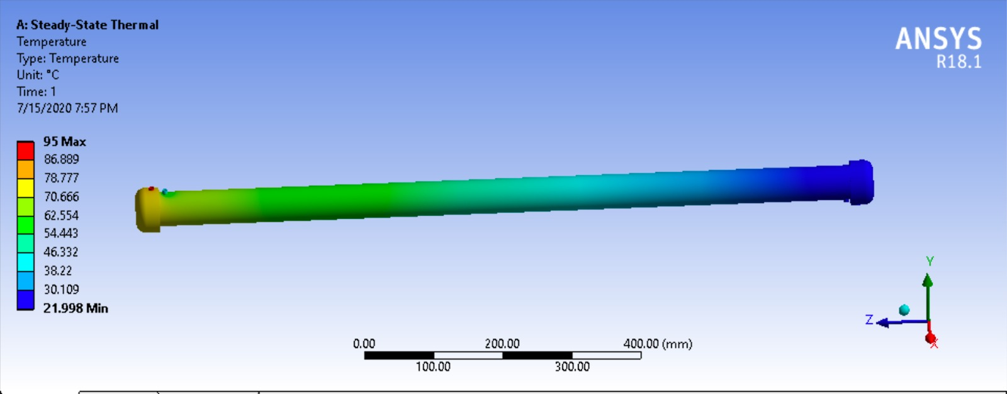

**FIGURE 4.2:** Shell and Tube heat exchanger temperature Results (Copper)

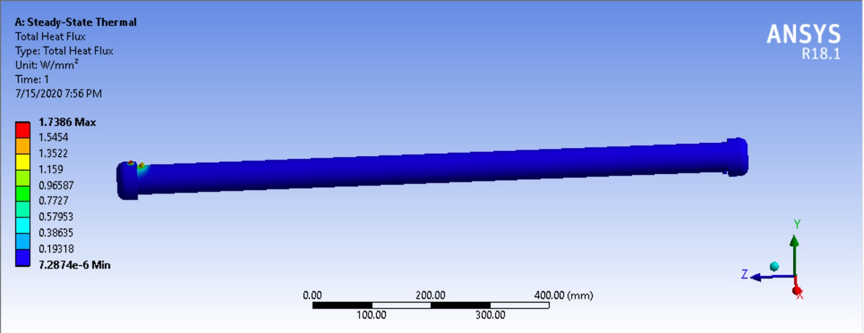

.

**FIGURE 4.3:** Total heat flux of Shell and Tube Heat exchanger (Copper)

We have assigned copper as the material of Shell and tube. Under this condition the maximum value of heat flux obtained is 1.7386 w/mm2,while the minimum value of heat flux is 7.2874e-006 w/mm2.

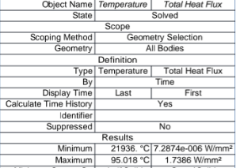

**Table 4.3:** Total heat flux values of heat exchanger (Copper)

**4.1.3 Making of Solid Model: Aluminium as material**

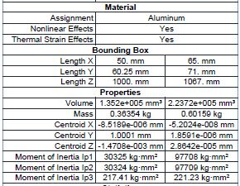

**Table 4.4:** Geometry of shell and tube heat exchanger (Aluminium)

Using the dimensions of shell and tube shown in table-4.4, we have made a solid model using ANSYS 18.1. The parts in assembly are as shown in figure-4.4.



**FIGURE 4.4:** Shell and Tube Heat exchanger model (Aluminium)

**4.1.4 Steady State Thermal Simulation:**

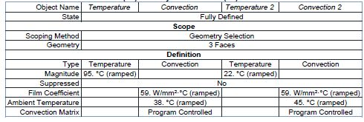

**Table 4.5:** Steady state thermal loads on Heat Exchanger (Aluminium)

This is the final and the most important step of our analysis. Here we have applied the thermal loads on the various faces and edges and simulated to get the value of thermal flux of the overall assembly. The thermal loads applied are shown in the figure-4.5.

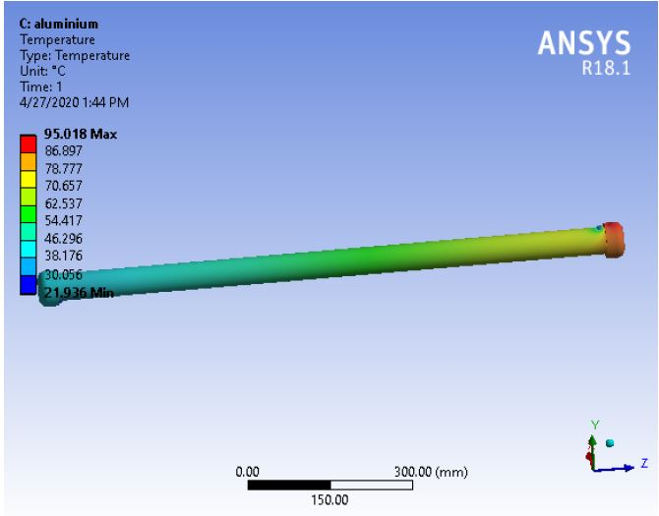

**FIGURE 4.5:** Temperature results of Shell and Tube heat exchanger (Aluminium)

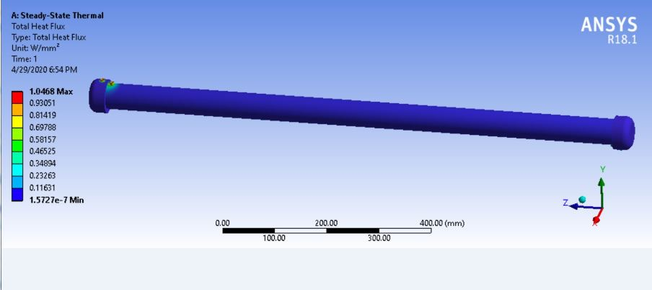

**FIGURE 4.6:** Total Heat Flux of Shell and Tube heat exchanger (Aluminium)

We have assigned aluminium as the material of Shell and tube. Under this condition the maximum value of heat flux obtained is 1.0468 w/mm2,while the minimum value of heat flux is 1.5731e-007 w/mm2.

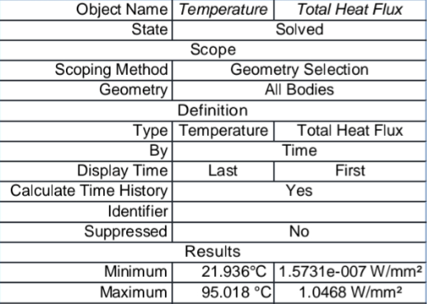

**Table 4.6:** Total heat flux values of heat exchanger (Aluminium)

**4.1.5 Making of Solid Model: Structural Steel as material**

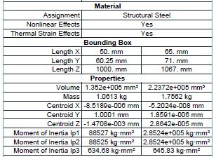

**Table 4.7:** Geometry of shell and tube Heat Exchanger (Structural steel)

Using the dimensions of shell and tubes shown in table-4.7, we have made a solid model using ANSYS 18.1. The parts in assembly are as shown in figure-4.7.



**FIGURE 4.7:** Shell and Tube Model (Structural Steel)

**4.1.6 Steady State Thermal Simulation:**

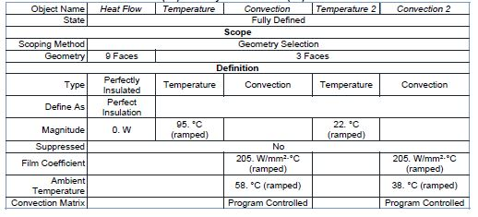

**Table 4.8:** Steady state thermal loads on Heat Exchanger (Structural Steel)

This is the final and the most important step of our analysis. Here we have applied the thermal loads on the various faces and edges and simulated to get the value of thermal flux of the overall assembly. The thermal loads applied are shown in the figure-4.8.

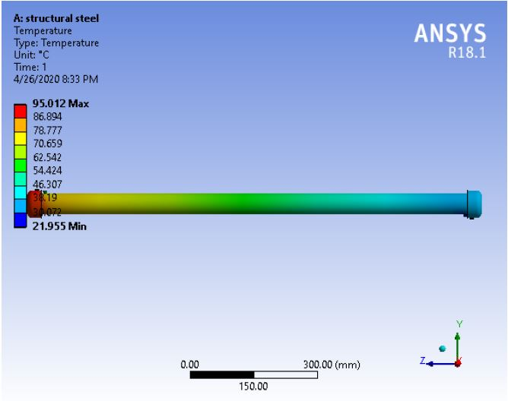

**FIGURE 4.8:** Temperature Results of Shell and Tube (Structural Steel)

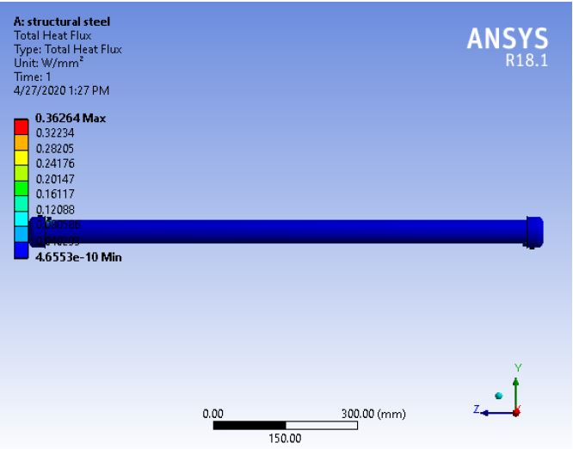

**FIGURE 4.9:** Total Heat Flux of Shell and Tube (Structural Steel)

We have assigned structural steel as the material of Shell and Tube. Under this condition the maximum value of heat flux obtained is 0.36264 𝑤/𝑚𝑚2, while the minimum value of heat flux is 4.6553e-10 w/mm2.

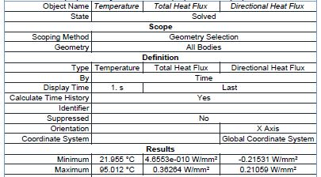

**Table 4.9:** Total heat flux values of heat exchanger (Structural Steel)

* + 1. **Making of Solid Model: Silicon Carbide as material**

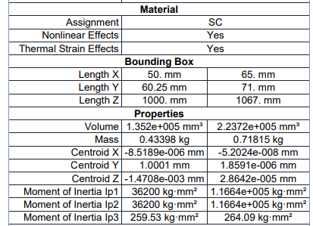

**Table 4.10:** Geometry of shell and tube Heat Exchanger (Silicon Carbide)

Using the dimensions of shell and tube shown in table-4.10, we have made a solid model using ANSYS 18.1. The parts in assembly are as shown in figure-4.10.

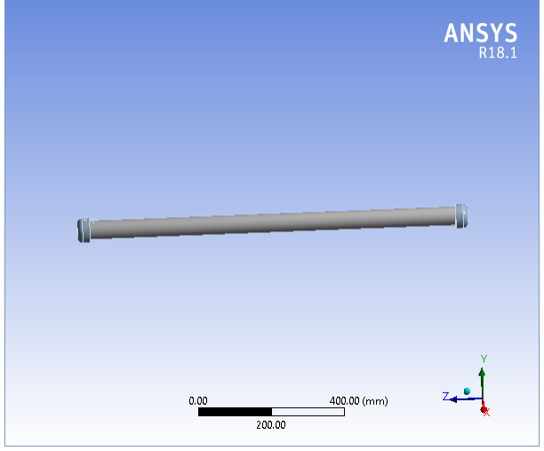

**FIGURE 4.10:** Shell and Tube Model (Silicon Carbide)

**5.1.8 Steady State Thermal Simulation:**

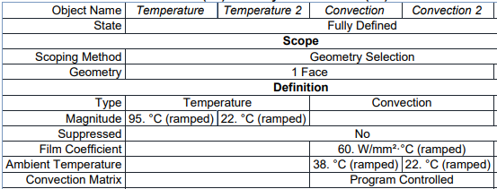

**Table 4.11:** Steady state thermal loads on Heat Exchanger (Silicon Carbide)

This is the final and the most important step of our analysis. Here we have applied the thermal loads on the various faces and edges and simulated to get the value of thermal flux of the overall assembly. The thermal loads applied are shown in the figure-4.11.

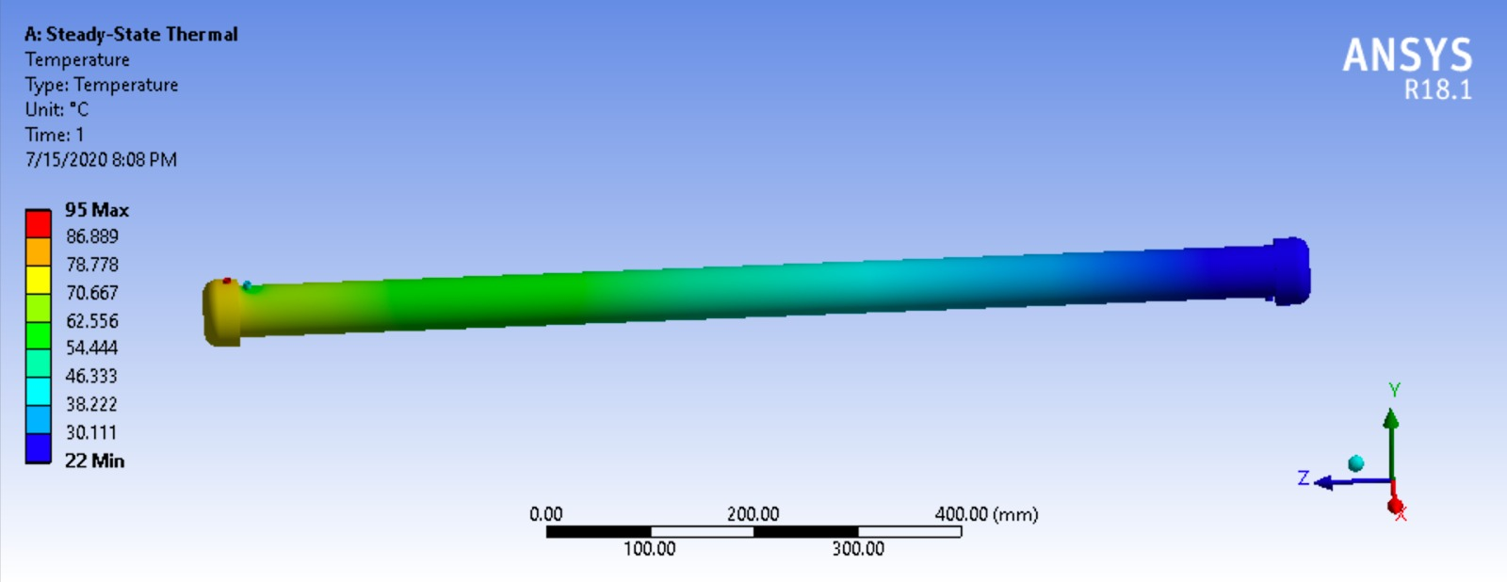

**FIGURE 4.11:** Temperature Results of Shell and Tube (SiliconCarbide)

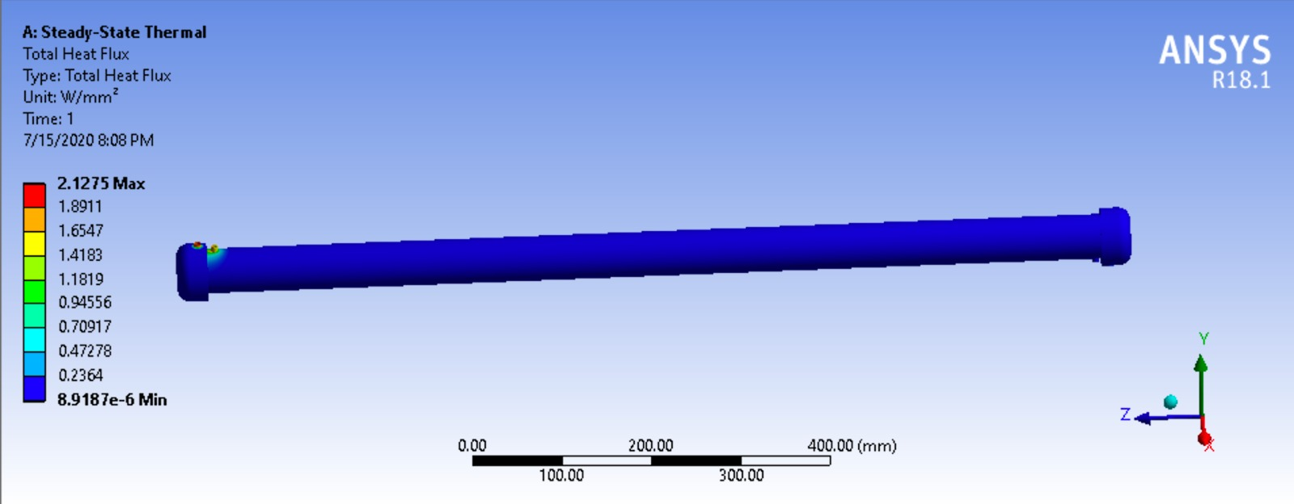

**FIGURE 4.12:** Total Heat Flux of Shell and Tube (SiliconCarbide)

We have assigned structural steel as the material of Shell while the tubes have been assigned structural steel. Under this condition the maximum value of heat flux obtained is 2.1275 𝑤/𝑚𝑚2, while the minimum value of heat flux is 8.9187e-6 w/mm2.

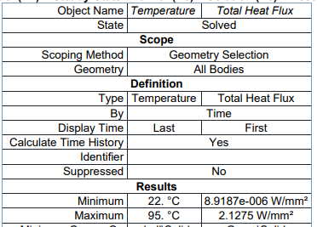

Table 4.12: Total heat flux values of heat exchanger (Silicon Carbide)

**4.1.9 Making of Solid Model: Copper-Graphene as material**

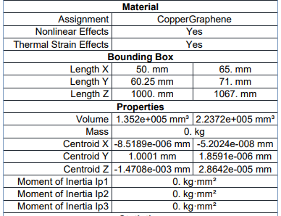

Table 4.13: Geometry of shell and tube Heat Exchanger (copper- Graphene)

Using the dimensions of shell and tube shown in table -4.13, we have made a solid model using ANSYS 18.1. The parts individually as well as in assembly are as shown in figure-4.13.

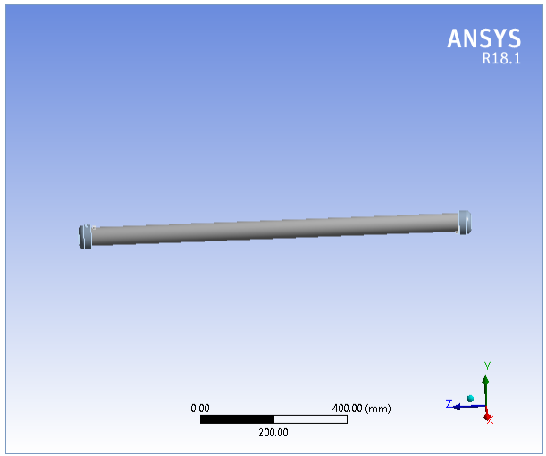

**FIGURE 4.13:** Shell and Tube model (Copper-Graphene)

**4.1.10 Steady State Thermal Simulation:**

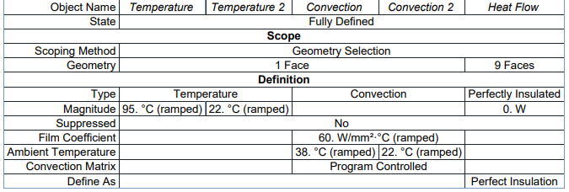

**Table 4.14:** Steady state thermal loads on Heat Exchanger (Copper-Graphene)

This is the final and the most important step of our analysis. Here we have applied the thermal loads on the various faces and edges and simulated to get the value of thermal flux of the overall assembly. The thermal loads applied are shown in the figure- 4.14.

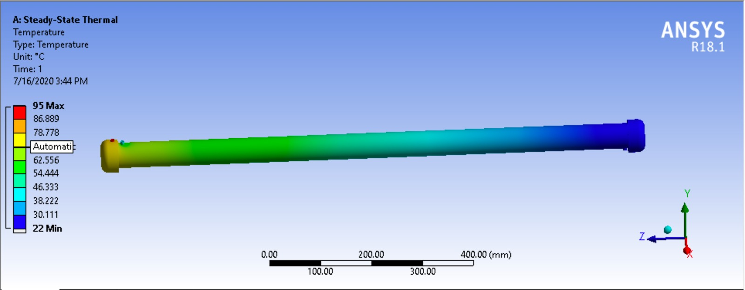

**FIGURE 4.14:** Temperature Results of Shell and Tube (Copper-Graphene)

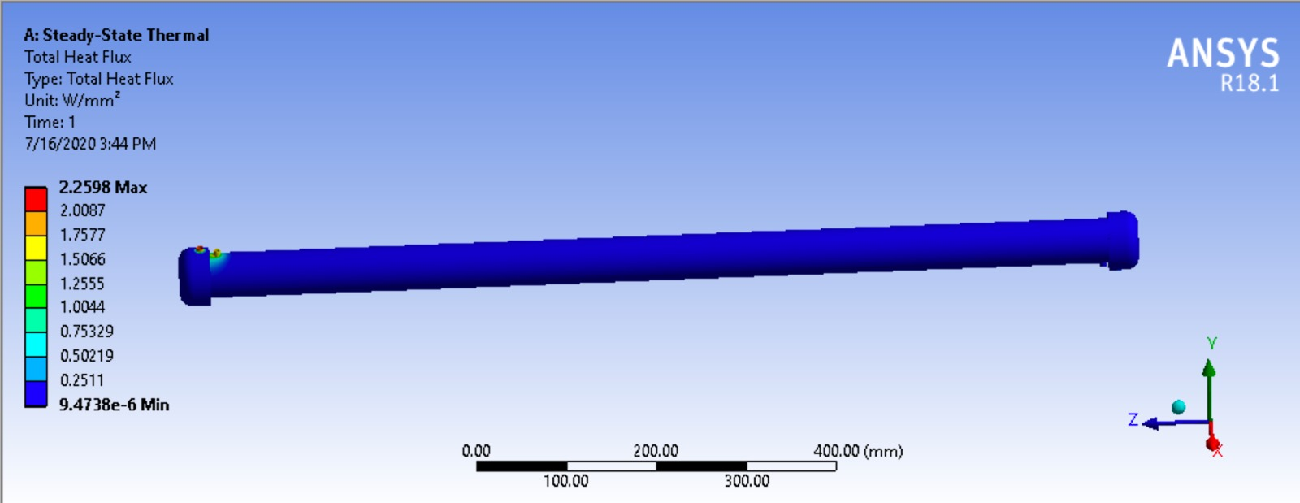

**FIGURE 4.15:** Total Heat Flux of Shell and Tube (Copper-Graphene)

We have assigned structural steel as the material of Shell while the tubes have been assigned structural steel. Under this condition the maximum value of heat flux obtained is 2.2598 𝑤/𝑚𝑚2, while the minimum value of heat flux is 9.4738e-006 w/mm2.

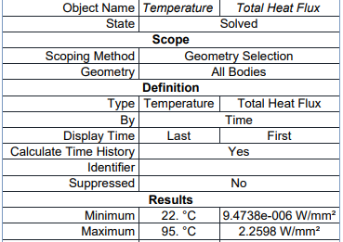

**Table 4.15:** Total heat flux values of heat exchanger (Copper-Graphene)

**4.2 Double piping heat exchanger:**

**4.2.1 Making of Solid Model: Copper as material**

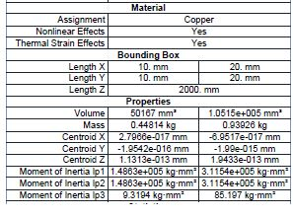

**Table 4.16:** geometry of tube in tube heat exchanger (Copper)

Using the dimensions of double pipe or tube in tube shown in table-4.16, we have made a solid model using ANSYS 18.1. The parts individually as well as in assembly are as shown in figure-4.16.

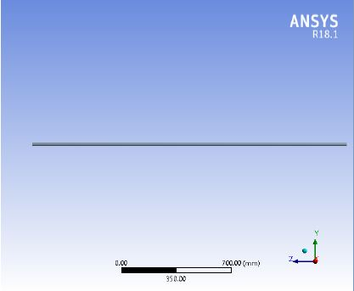

**FIGURE 4.16:** Tube in Tube heat Exchanger Model (Copper)

**4.2.2 Steady State Thermal Simulation:**

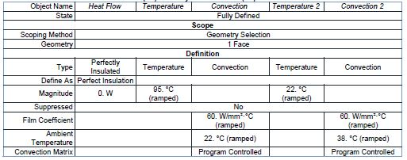

**Table 4.17:** Steady state thermal loads on Heat Exchanger (Copper)

This is the final and the most important step of our analysis. Here we have applied the thermal loads on the various faces and edges and simulated to get the value of thermal flux of the overall assembly. The thermal loads applied are shown in the figure-4.17.

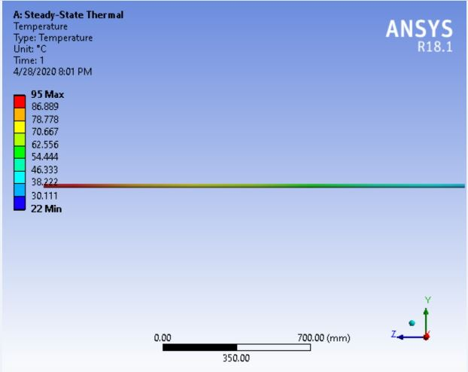

**FIGURE 4.17:** Tube in Tube heat Exchanger Temperature Results (Copper)

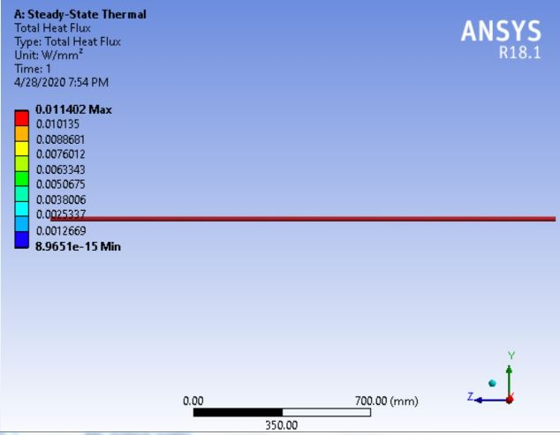

**FIGURE 4.18:** Total Heat Flux of Tube in Tube heat Exchanger (Copper)

We have assigned copper as the material of double pipe. Under this condition the maximum value of heat flux obtained is 0.011402 w/𝑚𝑚2, while the minimum value of heat flux is 8.9651e-15 w/mm2.

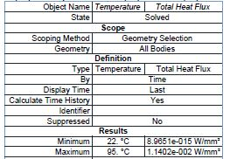

**Table 4.18:** Total heat flux values of heat Exchanger (Copper)

**4.2.3 Making of Solid Model: Aluminium as material**

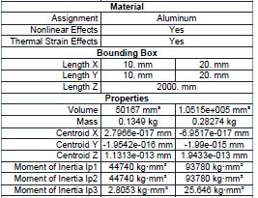

**Table 4.19:** Geometry of tube in tube heat exchanger (Aluminium)

Using the dimensions of double pipe or tube in tube shown in table -4.19, we have made a solid model using ANSYS 18.1. The parts in assembly are as shown in figure -4.19.



**FIGURE 4.19:** Tube in Tube heat Exchanger Model (Aluminum)

**4.2.4 Steady State Thermal Simulation:**

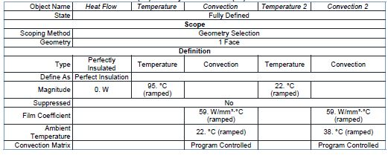

**Table 4.20:** Steady state thermal loads on Heat Exchanger (Aluminium)

This is the final and the most important step of our analysis. Here we have applied the thermal loads on the various faces and edges and simulated to get the value of thermal flux of the overall assembly. The thermal loads applied are shown in the figure- 4.20.

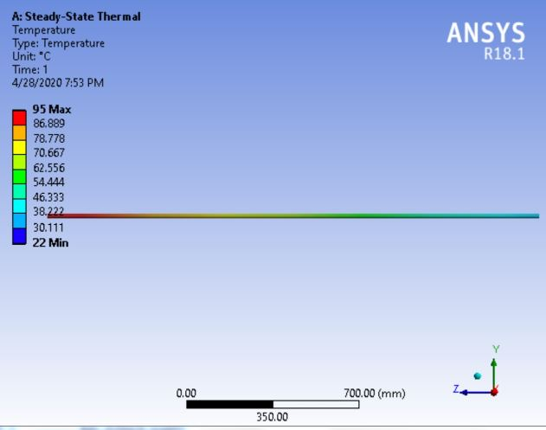

**FIGURE 4.20:** Temperature Results of Tube in Tube heat Exchanger (Aluminum)

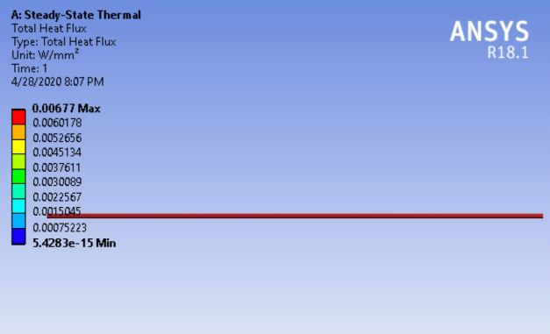

**FIGURE 4.21:** Total Heat Flux of Tube in Tube heat Exchanger (Aluminum)

We have assigned aluminium as the material of double pipe. Under this condition the maximum value of heat flux obtained is 0.00677w/𝑚𝑚2, while the minimum value of heat flux is 5.4283e-15 w/mm2.

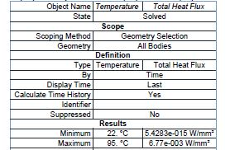

**Table 4.21:** Total heat flux values of heat exchanger (Aluminium)

**4.2.5 Making of Solid Model: Structural Steel as material**

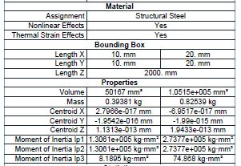

**Table 4.22:** Geometry of tube in tube heat exchanger (Structural Steel)

Using the dimensions of double pipe or tube in tube shown in table -4.22, we have made a solid model using ANSYS 18.1. The parts in assembly are as shown in figure-4.22.



**FIGURE 4.22:** Tube in Tube heat Exchanger Model (Structural Steel)

**4.2.6 Steady State Thermal Simulation:**

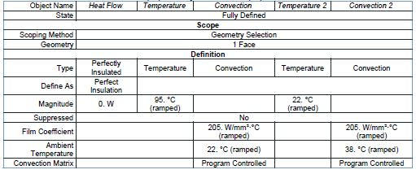

**Table 4.23:** Steady state thermal loads on Heat Exchanger (Structural Steel)

This is the final and the most important step of our analysis. Here we have applied the thermal loads on the various faces and edges and simulated to get the value of thermal flux of the overall assembly. The thermal loads applied are shown in the figure- 4.23.

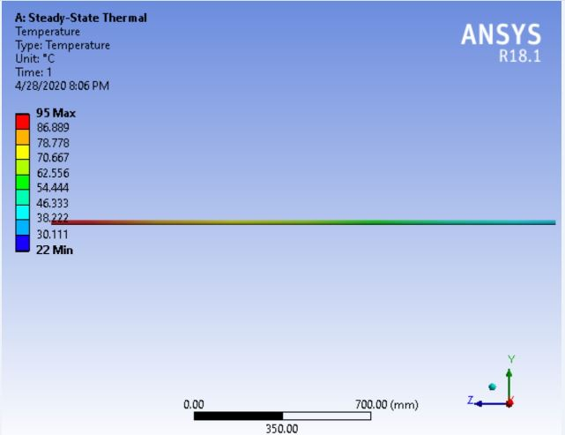

**FIGURE 4.23:** Temperature Results of Tube in Tube heat Exchanger (Structural Steel)

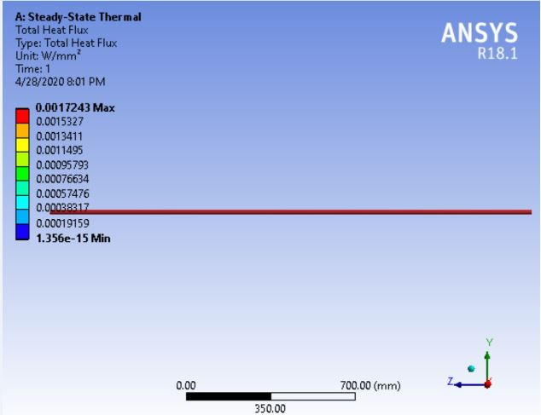

**FIGURE 4.24:** Total Heat Flux of Tube in Tube heat Exchanger (Structural Steel)

We have assigned structural steel as the material of double pipe. Under this condition the maximum value of heat flux obtained is 0.0017243w/𝑚𝑚2 while the minimum value of heat flux is 1.3e-015w/mm2.

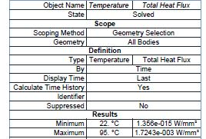

**Table 4.24:** Total heat flux values of heat exchanger (Structural Steel)

**4.2.7: Making of Solid Model: Silicon Carbide as material**

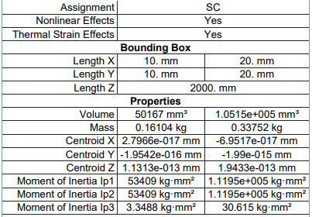

**Table 4.25:** Geometry of tube in tube heat exchanger (Silicon Carbide)

Using the dimensions of double pipe or tube in tube shown in table-4.25, we have made a solid model using ANSYS 18.1. The parts in assembly are as shown in figure -4.25.

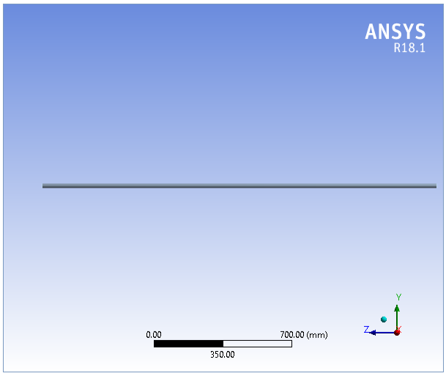

**FIGURE 4.25:** Tube in Tube heat Exchanger Model (Silicon carbide)

**4.2.8: Steady State Thermal Simulation:**

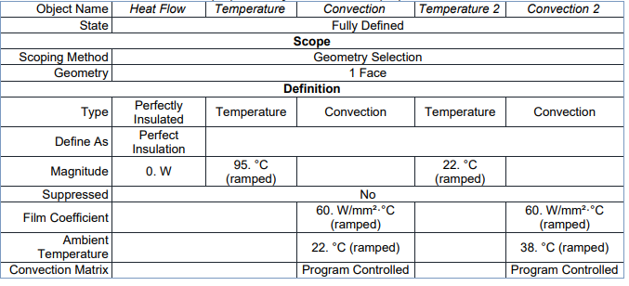

**Table 4.26:** Steady state thermal loads on Heat Exchanger (Silicon Carbide)

This is the final and the most important step of our analysis. Here we have applied the thermal loads on the various faces and edges and simulated to get the value of thermal flux of the overall assembly. The thermal loads applied are shown in the figure- 4.26.

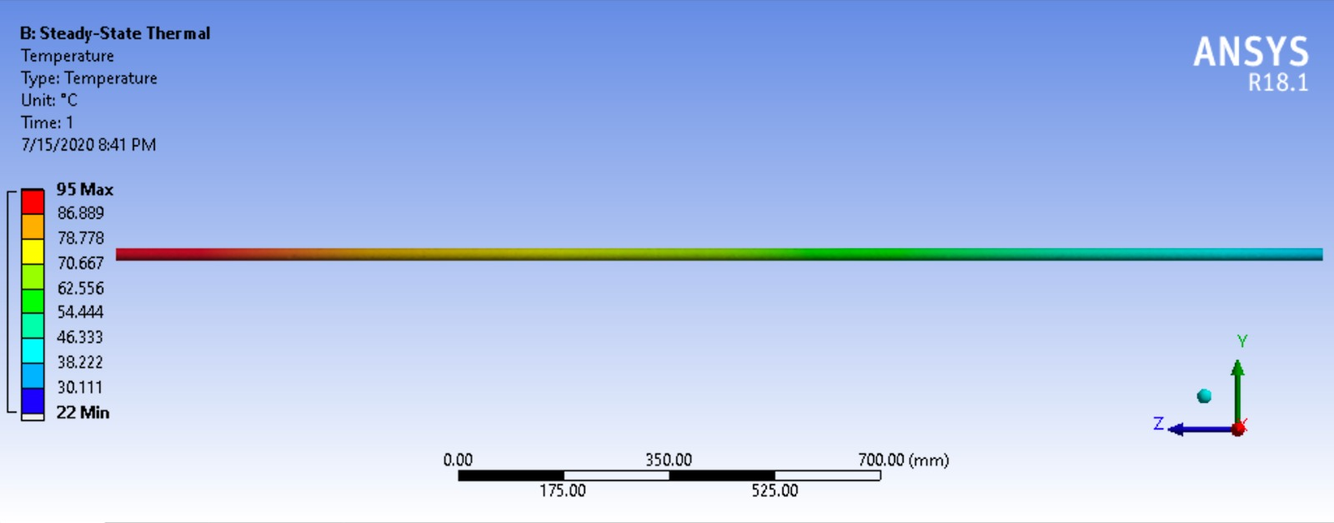

**FIGURE 4.26:** Temperature Results of Tube in Tube heat Exchanger (Silicon carbide)

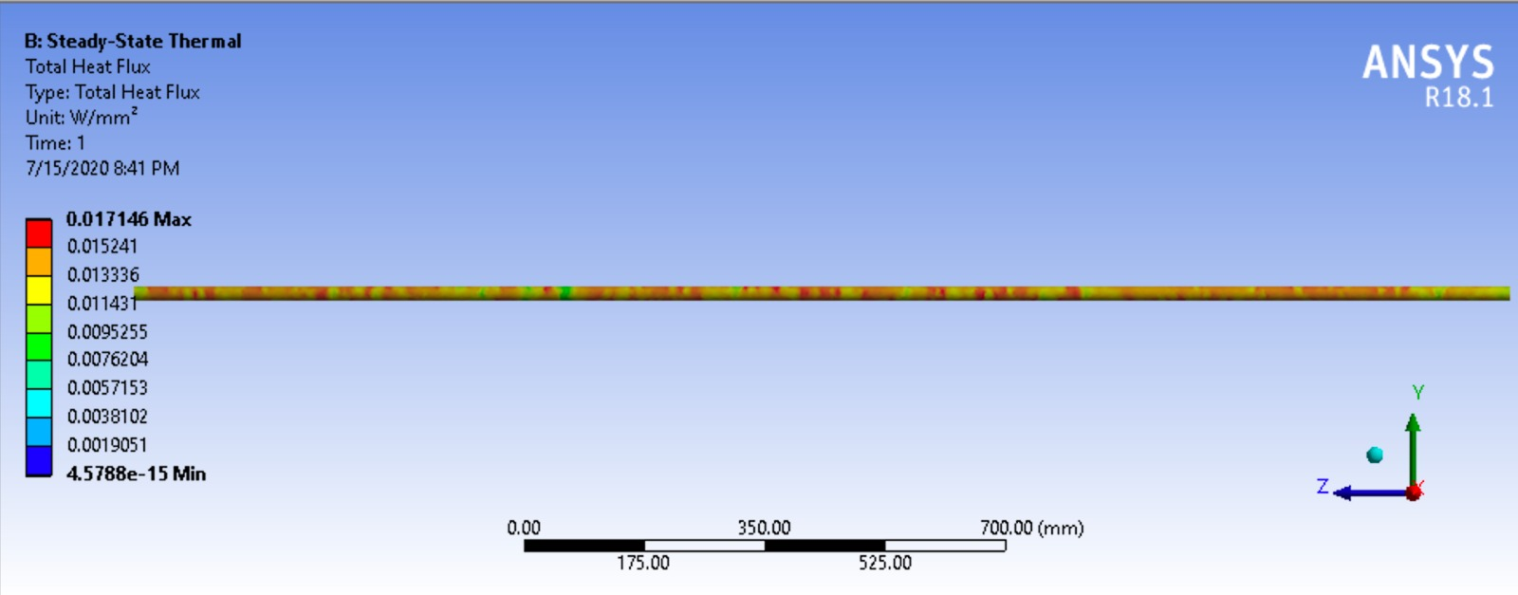

**FIGURE 4.27:** Total Heat Flux of Tube in Tube heat Exchanger (Silicon Carbide)

We have assigned structural steel as the material of double pipe. Under this condition the maximum value of heat flux obtained is 0.017146w/𝑚𝑚2 while the minimum value of heat flux is 4.5788e-015w/mm2.

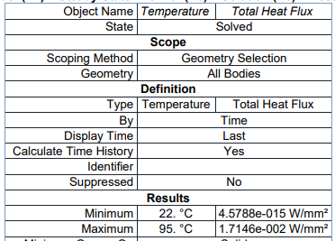

**Table 4.27:** Total heat flux values of heat exchanger (Silicon Carbide)

**4.2.9 Making of Solid Model: Copper-Graphene as material:**

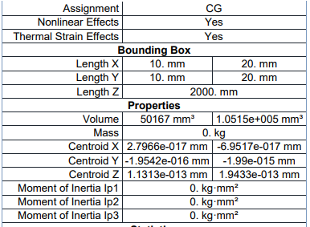

**Table 4.28:** Geometry of tube in tube heat exchanger (Copper- Graphene)

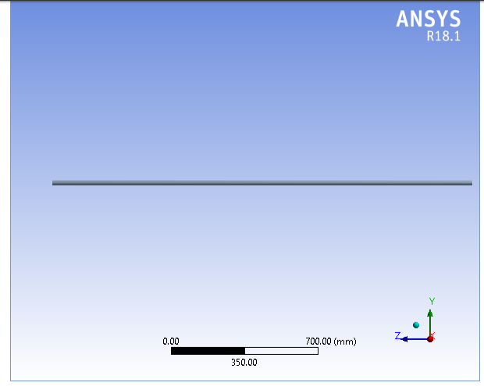

**FIGURE 4.28:** Tube in Tube heat Exchanger Model (Copper-Graphene)

**4.2.10 Steady State Thermal Simulation:**

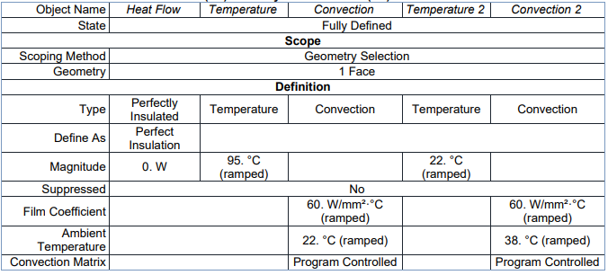

**Table 4.29**: Steady state thermal loads on Heat Exchanger (Copper-Graphene)

This is the final and the most important step of our analysis. Here we have applied the thermal loads on the various faces and edges and simulated to get the value of thermal flux of the overall assembly. The thermal loads applied are shown in the figure- 4.29.

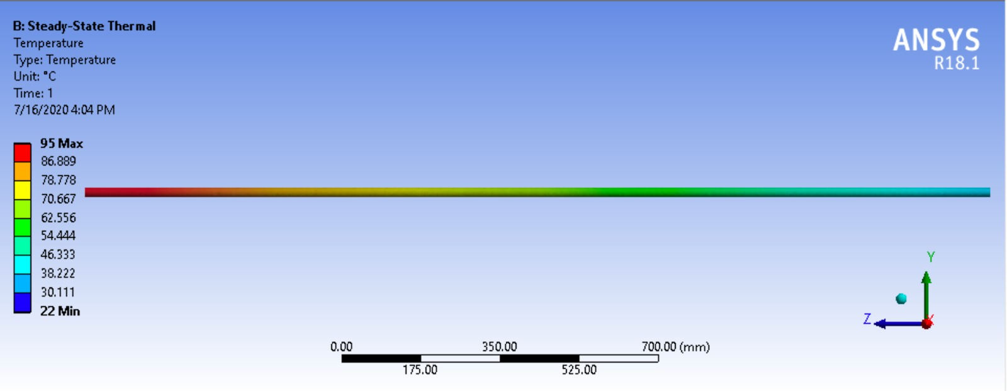

**FIGURE 4.29:** Temperature Results of Tube in Tube heat Exchanger (Copper-Graphene)

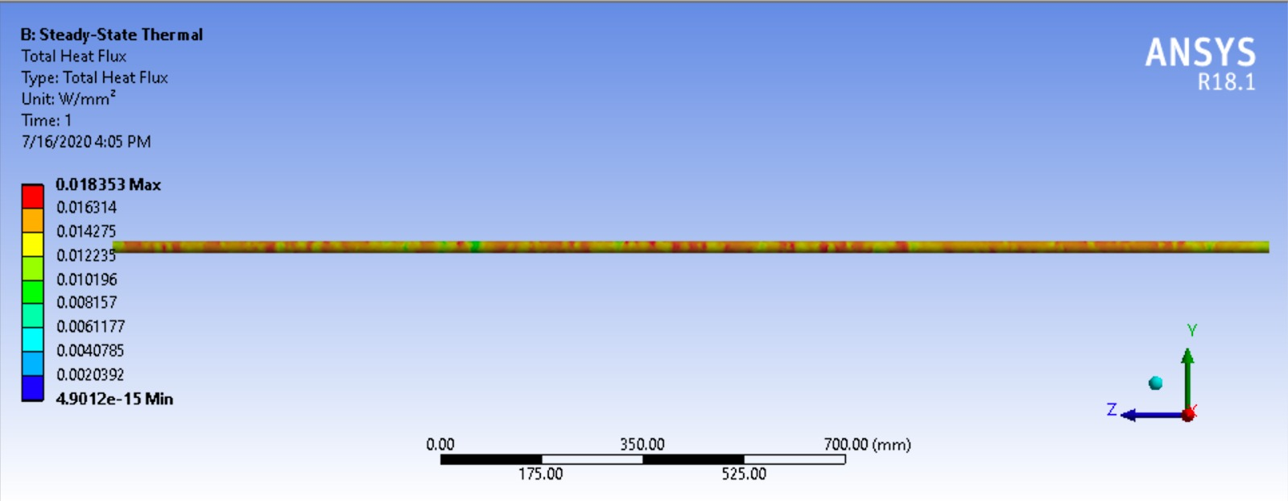

**FIGURE 4.30:** Total Heat Flux of Tube in Tube heat Exchanger (Copper-Graphene)

Then we have assigned copper-Graphene as the material of double pipe. Under this condition the maximum value of heat flux obtained is 0.018353w/𝑚𝑚2 while the minimum value of heat flux is 4.9012e-015w/mm2.

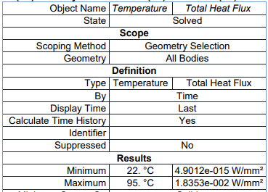

**Table 4.30:** Total heat flux values of heat exchanger (Copper-Graphene)

**4.3 Shell and Coil heat exchanger:**

**4.3.1 Making of Solid Model: Copper as material**

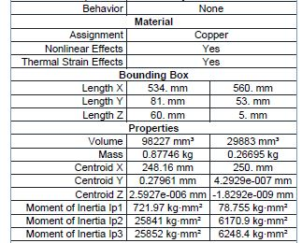

**Table 4.31:** Geometry of shell and coil heat exchanger (Copper)

Using the dimensions of shell and coil shown in table-4.31 we have made a solid model using ANSYS 18.1. The parts in assembly are as shown in figure -4.31

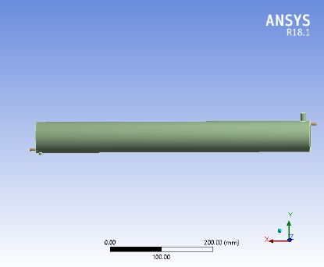

**FIGURE 4.31:** Shell and Coil Heat Exchanger Model (Copper)

**4.3.2 Steady State Thermal Simulation:**

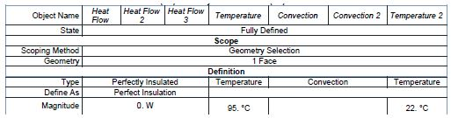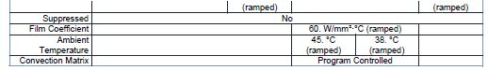

This is the final and the most important step of our analysis. Here we have applied the thermal loads on the various faces and edges and simulated to get the value of thermal flux of the overall assembly. The thermal loads applied are shown in the figure-4.32.

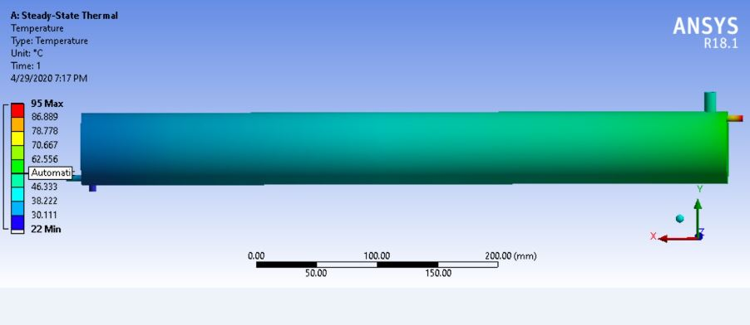

**FIGURE 4.32:** Temperature Results of Shell and Coil Heat Exchanger (Copper)

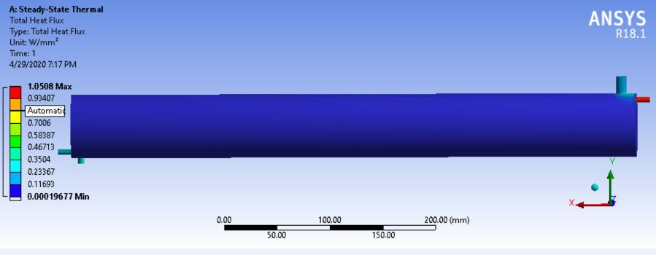

**FIGURE 4.33:** Total Heat Flux of Shell and Coil Heat Exchanger (Copper)

We have assigned copper as the material of Shell and Coil. Under this condition the maximum value of heat flux obtained is 1.0508 w/𝑚𝑚2 while the minimum value of heat flux is 0.00019677w/mm2.

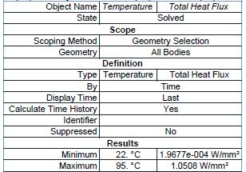

**Table 4.33:** Total heat flux values of heat exchanger (Copper)

**4.3.3 Making of Solid Model: Aluminium as material**

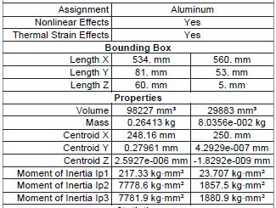

**Table 4.34:** Geometry of shell and coil heat exchanger (Aluminium)

Using the dimensions of shell and coil shown in table-4.34, we have made a solid model using ANSYS 18.1. The parts in assembly are as shown in figure-4.34.



**FIGURE 4.34:** Shell and Coil Heat Exchanger Model (Aluminum)

**4.3.4 Steady State Thermal Simulation:**

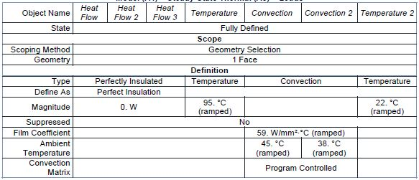

**Table 4.35:** Steady state thermal loads on Heat Exchanger (Aluminium)

This is the final and the most important step of our analysis. Here we have applied the thermal loads on the various faces and edges and simulated to get the value of thermal flux of the overall assembly. The thermal loads applied are shown in the figure- 4.35.

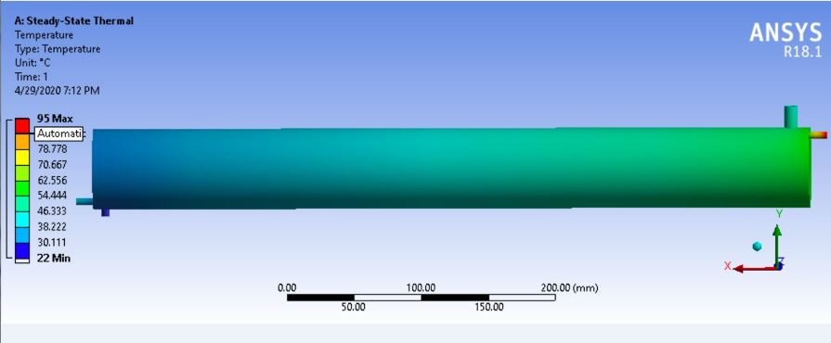

**FIGURE 4.35:** Temperature Results of Shell and Coil Heat Exchanger (Aluminum)

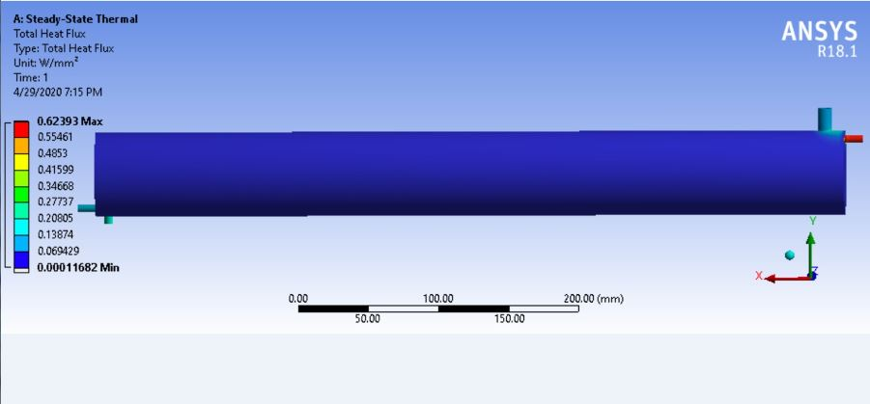   
**FIGURE 4.36:** Total Heat Flux of Shell and Coil Heat Exchanger (Aluminum)

We have assigned Aluminium as the material of Shell and Coil. Under this condition the maximum value of heat flux obtained is 0.62393 w/𝑚𝑚2 while the minimum value of heat flux is 0.00011682 w/mm2.

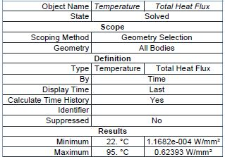

**Table 4.36:** Total heat flux values of heat exchanger (Aluminium)

**4.3.5 Making of Solid Model: Structural Steel as material**

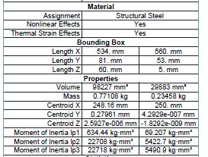

**Table 4.37:** Geometry of shell and coil heat exchanger (Structural Steel)

Using the dimensions of shell and coil shown in table-4.37, we have made a solid model using ANSYS 18.1. The parts in assembly are as shown in figure-4.37.



**FIGURE 4.37:** Shell and Coil Heat Exchanger Model (Structural Steel)

**4.3.6 Steady State Thermal Simulation:**

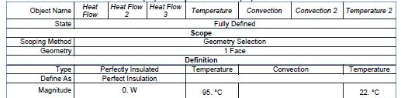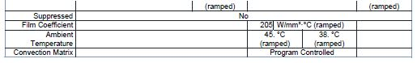

**Table 4.38:** Steady state thermal loads on Heat Exchanger (Structural Steel)

This is the final and the most important step of our analysis. Here we have applied the thermal loads on the various faces and edges and simulated to get the value of thermal flux of the overall assembly. The thermal loads applied are shown in the figure- 4.38.

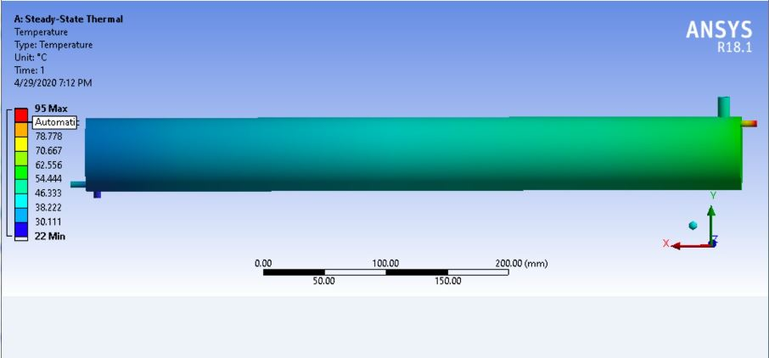

**FIGURE 4.38:** Temperature Results of Shell and Coil Heat Exchanger (Structural Steel)

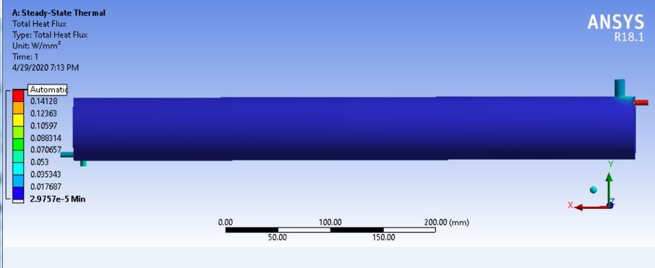

**FIGURE 4.39:** Total Heat Flux of Shell and Coil Heat Exchanger (Structural Steel)

We have assigned structural steel as the material of Shell and coil. Under this condition the maximum value of heat flux obtained is 0.15894 w/𝑚𝑚2 while the minimum value of heat flux is 2.9757e-005 w/mm2.

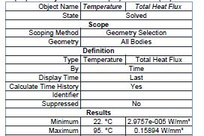

**Table 4.39:** Total heat flux values of heat exchanger (Structural Steel)

**4.3.7 Making of Solid Model: Silicon Carbide as material**

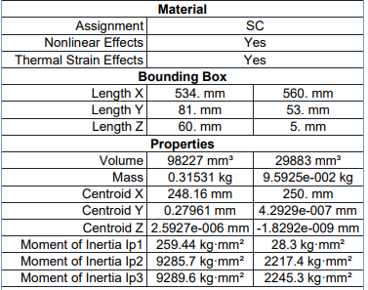

**Table 4.40:** Geometry of shell and coil heat exchanger (Silicon Carbide)

Using the dimensions of shell and coil shown in table- 4.40, we have made a solid model using ANSYS 18.1. The parts in assembly are as shown in figure-4.40.

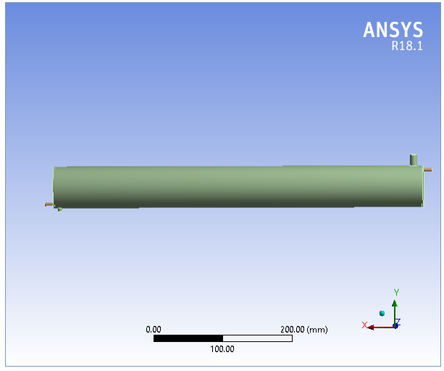

**FIGURE 4.40:** Shell and Coil Heat Exchanger Model (Silicon Carbide)

**4.3.8 Steady State Thermal Simulation:**

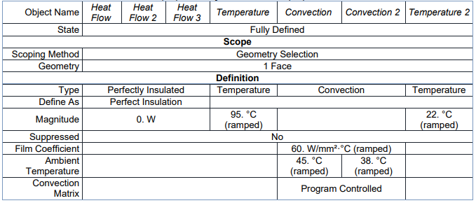

**Table 4.41:** Steady state thermal loads on Heat Exchanger (Silicon Carbide )

This is the final and the most important step of our analysis. Here we have applied the thermal loads on the various faces and edges and simulated to get the value of thermal flux of the overall assembly. The thermal loads applied are shown in the figure-4.41.

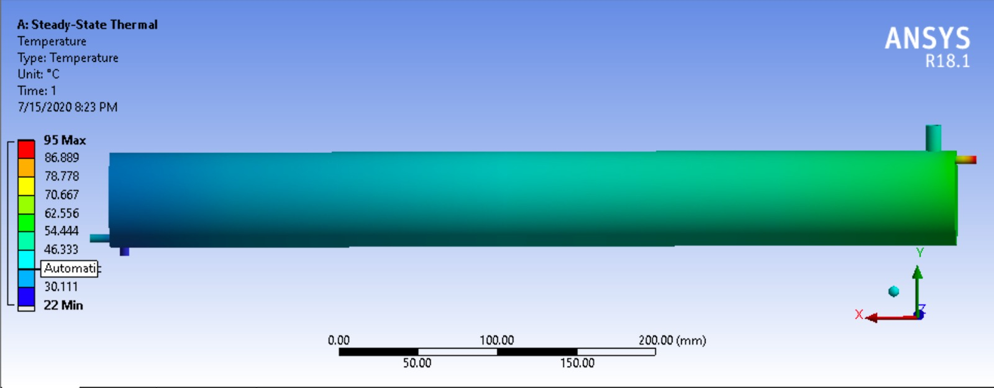

**FIGURE 4.41:** Temperature Results of Shell and Coil Heat Exchanger (Silicon Carbide)

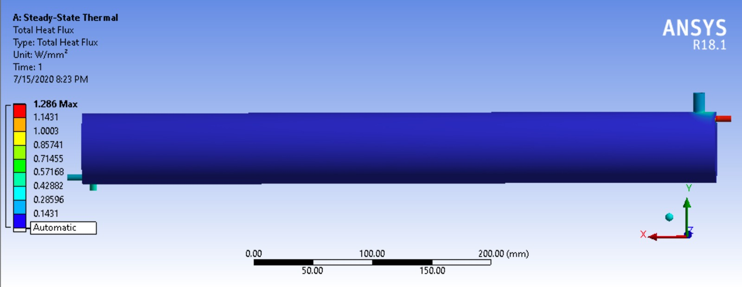

**FIGURE 4.42:** Total Heat Flux of Shell and Coil Heat Exchanger (Silicon Carbide)

We have assigned Silicon Carbide as the material of Shell and coil. Under this condition the maximum value of heat flux obtained is 1.286 w/𝑚𝑚2 while the minimum value of heat flux is 2.4082e-004 w/mm2.

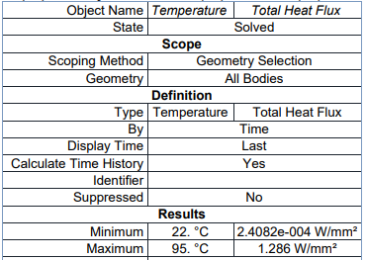

**Table 4.42:** Total heat flux values of heat exchanger (Silicon Carbide)

**4.3.9 Making of Solid Model: Copper-Graphene as material:**

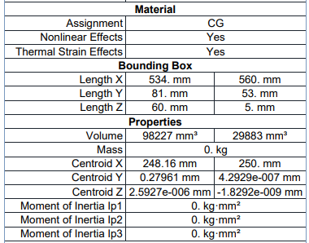

**Table 4.43:** Geometry of shell and coil heat exchanger (Copper- Graphene)

Using the dimensions of shell and coil shown in table-4.43, we have made a solid model using ANSYS 18.1. The parts in assembly are as shown in figure-4.43.

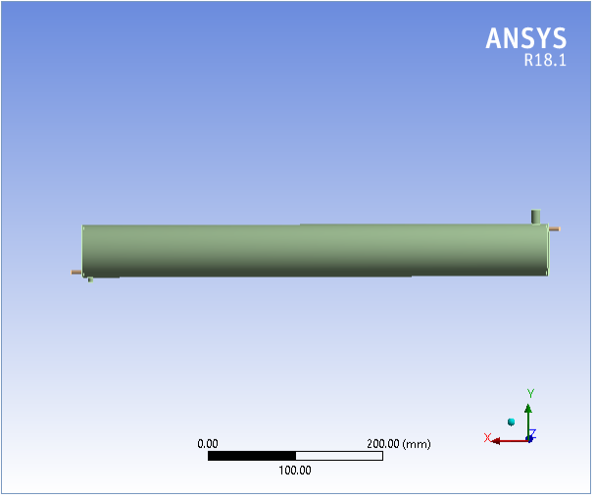

**FIGURE 4.43:** Shell and Coil Heat Exchanger Model (Copper-Graphene)

**4.3.10 Steady State Thermal Simulation:**

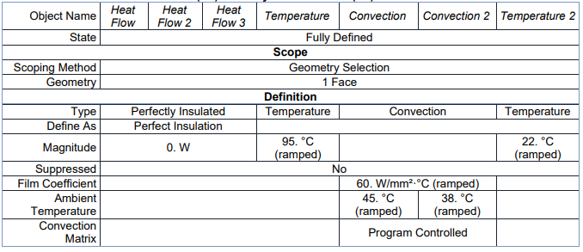

**Table 4.44:** Steady state thermal loads on Heat Exchanger (Copper- Graphene)

This is the final and the most important step of our analysis. Here we have applied the thermal loads on the various faces and edges and simulated to get the value of thermal flux of the overall assembly. The thermal loads applied are shown in the figure-4.44.

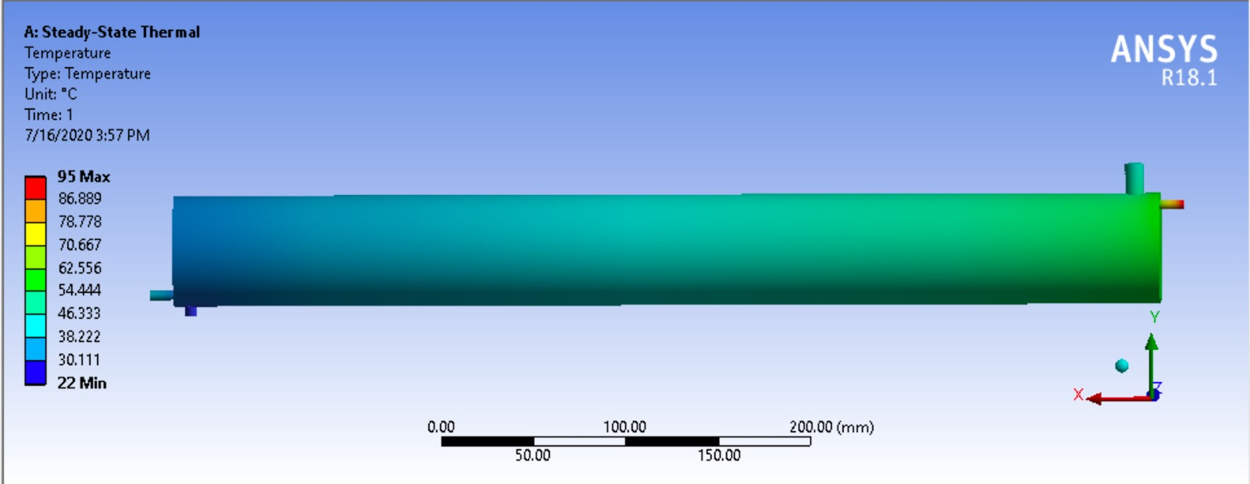

**FIGURE 4.44:** Temperature Results of Shell and Coil Heat Exchanger (Copper-Graphene)

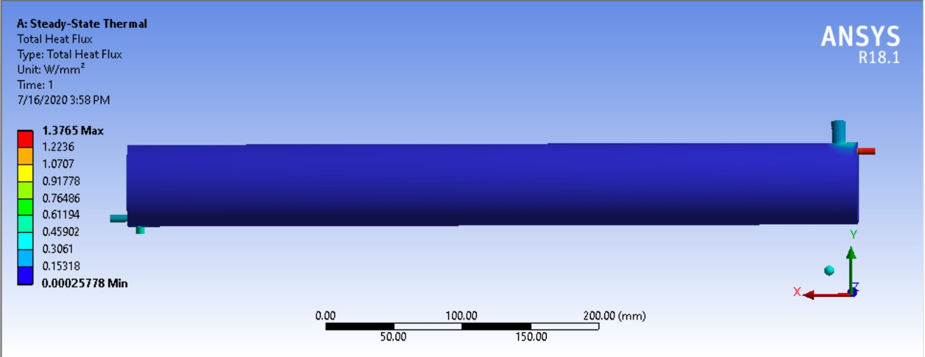

**FIGURE 4.45:** Total Heat Flux of Shell and Coil Heat Exchanger (Copper-Graphene)

We have assigned Copper-Graphene as the material of Shell and Coil. Under this condition the maximum value of heat flux obtained is 1.3765 w/mm2 , while the minimum value of heat flux is 2.5778e-004 w/mm2.

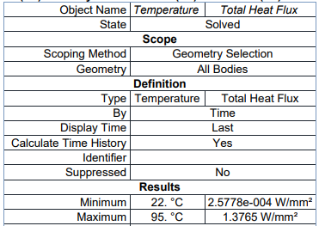

**Table 4.45:** Total heat flux values of heat exchanger (Copper-Graphene)

# 5. CONCLUSION

# The RESULTS of the above study may be summarized as follows:

**Shell and tube heat exchanger:**

|  |  |  |
| --- | --- | --- |
| Material | Minimum heat flux (w/mm2) | Maximum heat flux(w/mm2) |
| Copper | 7.2874e-006 | 1.7386 |
| Aluminium | 1.5731e-007 | 1.0468 |
| Structural Steel | 4.6553e-010 | 0.36284 |
| Silicon Carbide | 8.9187e-006 | 2.1275 |
| **Copper-Graphene** | **9.4738e-006** | **2.2598** |

**Double piping heat exchanger:**

|  |  |  |
| --- | --- | --- |
| Material | Minimum heat flux  (w/mm2) | Maximum heat  flux(w/mm2) |
| Copper | 8.9651e-015 | 0.011402 |
| Aluminium | 5.4283e-015 | 0.00677 |
| Structural Steel | 1.356e-015 | 0.0017243 |
| Silicon Carbide | 4.5788e-15 | 0.017146 |
| Copper -Graphene | **4.9012e-15** | **0.018353** |

**Shell and coil heat exchanger:**

|  |  |  |
| --- | --- | --- |
| Material | Minimum heat flux  (w/mm2) | Maximum heat  flux(w/mm2) |
| Copper | 1.9677e-004 | 1.0508 |
| Aluminium | 1.1682e-004 | 0.62393 |
| Structural Steel | 2.9757e-005 | 0.15894 |
| Silicon Carbide | - | 1.286 |
| Copper -Graphene | **0.00025773** | **1.3765** |

From this study, it is clear that:

* If we assign copper-graphene composite to the whole assembly then we shall get the best possible value of heat flux amongst the discussed materials; however that will also be a very costly affair when compared to all other materials . Secondly the outer surface of shell is generally insulated so that it may be assumed that no heat transfer is taking place in between shell and surroundings, hence it will be a good deal to assign shell steel and coils copper-graphene.
* By using Copper-Graphene as material of Heat Exchanger, Heat flux of heat exchanger is increased by 6.74435%, when compared to Silicon Carbide.
* We may also employ Silicon Carbide as the material of coils, as it is second to none than copper-graphene as far as heat transfer is concerned. One additional property of Silicon Carbide is its lower cost.
* By using Copper as material of Heat Exchanger, Heat flux value is increased by 22.37575%, when compared to Aluminium..
* Copper can be used when greater material economy is not required.
* Aluminium has the advantage of lighter weight and Steels are also moderate conductors of heat and can be employed, in case greater material economy is desired.
* By using Copper as material of Heat Exchanger, Heat flux value is increased by 67.64%, when compared to Aluminium.

**REFERENCES**

* Hari Haran, Ravindra Reddy and Sreehari, “Thermal Analysis of Shell and Tube Heat Exchanger Using C and Ansys”, International Journal of Computer Trends and Technology (IJCTT) – volume 4 Issue 7– July 2013
* Paresh Patel and Amitesh Paul, International Journal of Engineering Research & Technology (IJERT), ISSN: 2278-0181 Volume 1 Issue 8, October-2012.
* Gopi Chand, Prof. A. V. N. L. Sharma, G. Vijay Kumar, A. Srividya, “Thermal Analysis of shell and tube heat Exchanger using MATLAB and FLOEFD solid”, International Journal of Engineering Research & Technology (IJRET), Nov 2012 Volume: 1 Issue: 3276 – 281, ISSN: 2319 – 1163.
* P. S. Gowthaman and S. Sathish, “Analysis of Segmental and Helical Baffle in Shell and tube Heat Exchanger”, International Journal of Current Engineering and Technology, Special Issue-2 (Feb 2014).
* Ender Ozden, Ilker Tari, “Shell Side CFD Analysis of A Small Shell and Tube Heat Exchanger”, Middle East Technical University, 2010.